|  |  |
| --- | --- |
| **EMPLOYEE ATTRITION CLASSIFICATION DATASET**  An In-Depth Synthetic Simulation for Attrition Analysis and Prediction | Abstract  This report details the process of deploying a machine learning model using AWS SageMaker, using the Employee Attrition Classification dataset from Kaggle. The dataset which includes various features related to employee demographics, job roles, serves as a basis for predicting employee turnover within an organization. The report outlines the entire workflow, from data preparation to model training, evaluation, and deployment. Key aspects of AWS are explored, including configuring the SageMaker environment, training the model, and deploying it for inference. Additionally, the project required the management of data and model files, which were stored in an Amazon S3 bucket. The objective is to demonstrate a practical application of AWS SageMaker in implementing machine learning solutions for business problems, showcasing the effectiveness and efficiency of cloud-based machine learning deployments in addressing employee attrition and enhancing organizational retention strategies.  Thapelo Lenzi  Deploying Machine Learning Models in AWS SageMaker |

**Dataset**

This dataset consists of 74 498 entries with each including a unique Employee ID and features that influence employee attrition. The goal is to understand the factors contributing to attrition (Whether the employee has left the company, encoded as 0 for stayed and 1 for left) and develop predictive models to identify at-risk employees. The features include:

* Age
* Gender
* Years at company
* Monthly income
* Job role
* Work-life balance
* Education level
* And more

[**https://www.kaggle.com/datasets/stealthtechnologies/employee-attritiondataset?resource=download&select=train.csv**](https://www.kaggle.com/datasets/stealthtechnologies/employee-attrition-dataset?resource=download&select=train.csv)

**Data Extraction**

Obtaining the dataset from Kaggle:

Search for the Employee Attrition Classification dataset on Kaggle.



Sign In:



Go to the dataset page and click on the download button to manually download the dataset:

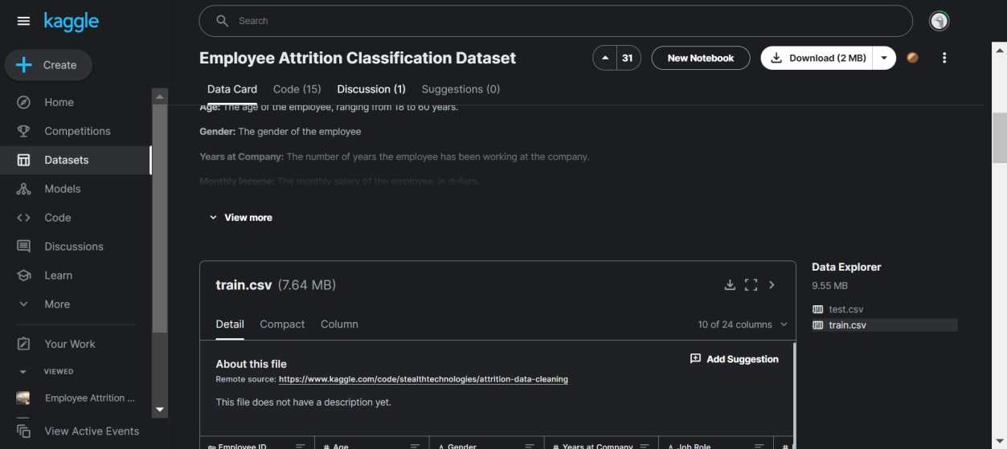

**Data Preparation**

The data preparation and exploratory data analysis stages of this project are done using Google Colab.

Loading Libraries, Importing necessary libraries for data manipulation and visualization:

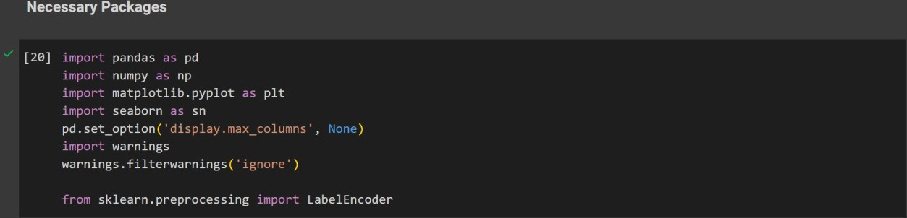

Loading the data into a pandas data frame:



**Exploratory Data Analysis**

The overview of the dataset:

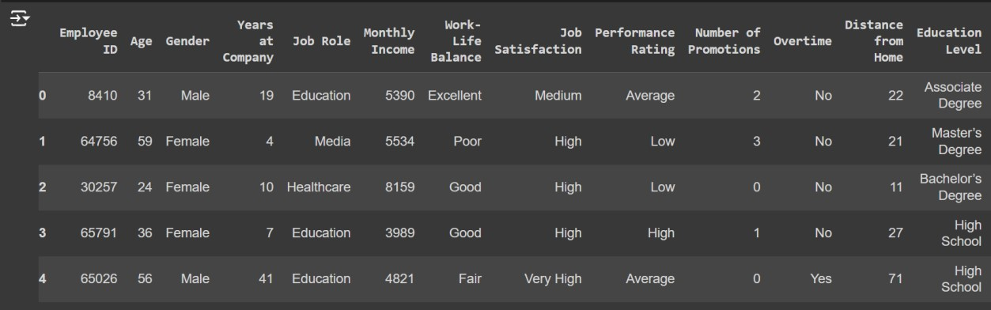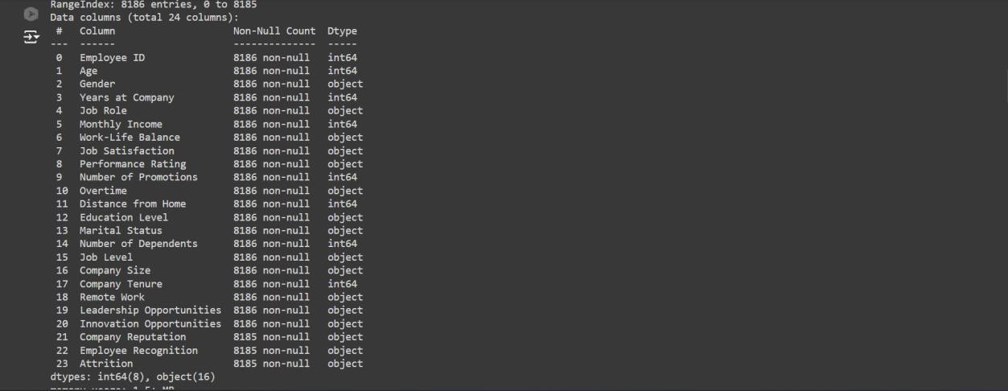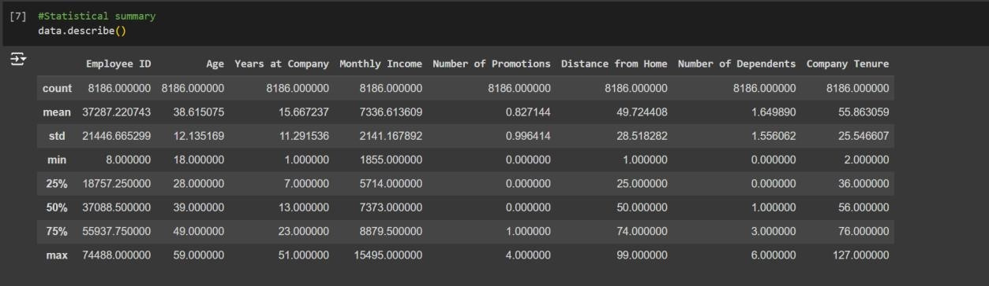

The above snippets provide a sample of the data and understand the structure of the dataset, including column names and initial values. They provide the dimensions of the dataset, which can be observed as 8185 rows and 24 columns, which help in understanding the size of the dataset. The data type and statistical summaries, include the number of non-null entries in each column and datatypes together with metrics such as the mean, minimum and maximum. These help with understanding the distribution and range of the numeric data and identifying any missing values. From the above, it can be noted that the dataset has two data types (int64 and object) and the last three columns have some null values.

**Handling Missing Data**

The missing values can be explicitly displayed, as shown below. Since there is only one value missing in each of the three columns and there are a lot of entries, the missing values can be dropped and will not make any significant change in the analysis.

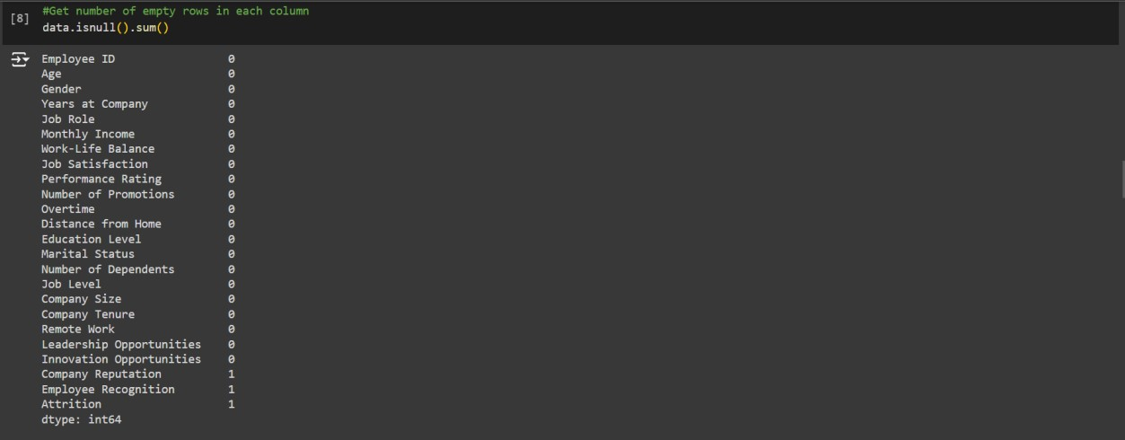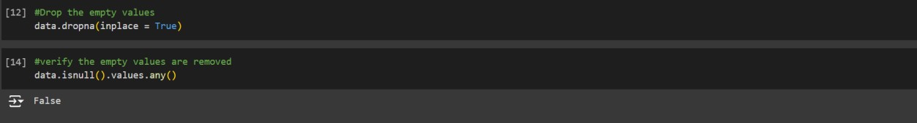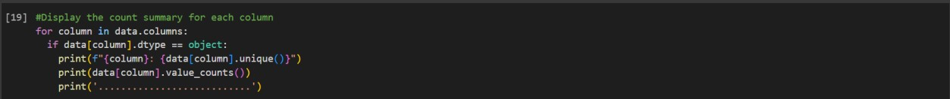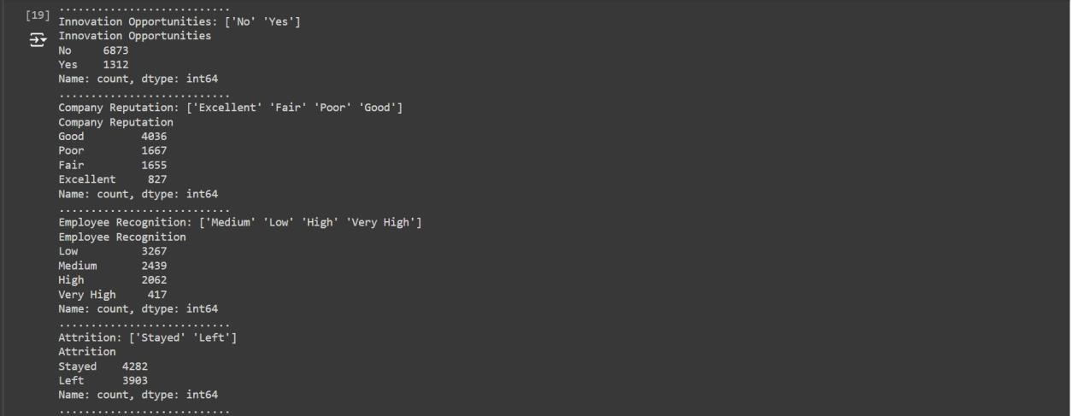

The above is a summary of each column. In the dependent column (Attrition), there are two unique values with ‘Stayed’ having the greater count.

**Feature Engineering**

The dependent column is originally in text form. In order for it to be used in the model, it is converted to numerical form using the LabelEncoder from the scikit-learn library, as seen in the snippet below.

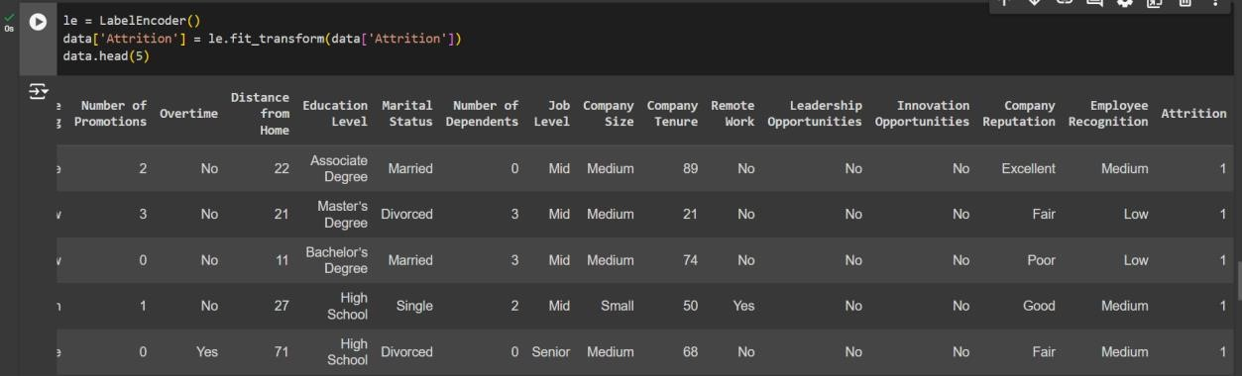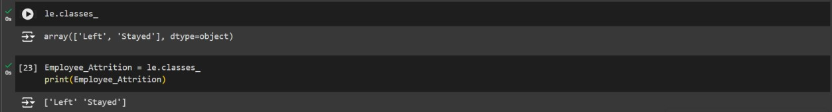

**Data Visualization using PowerBI Desktop**

Connecting to Python Script in PowerBI Desktop:

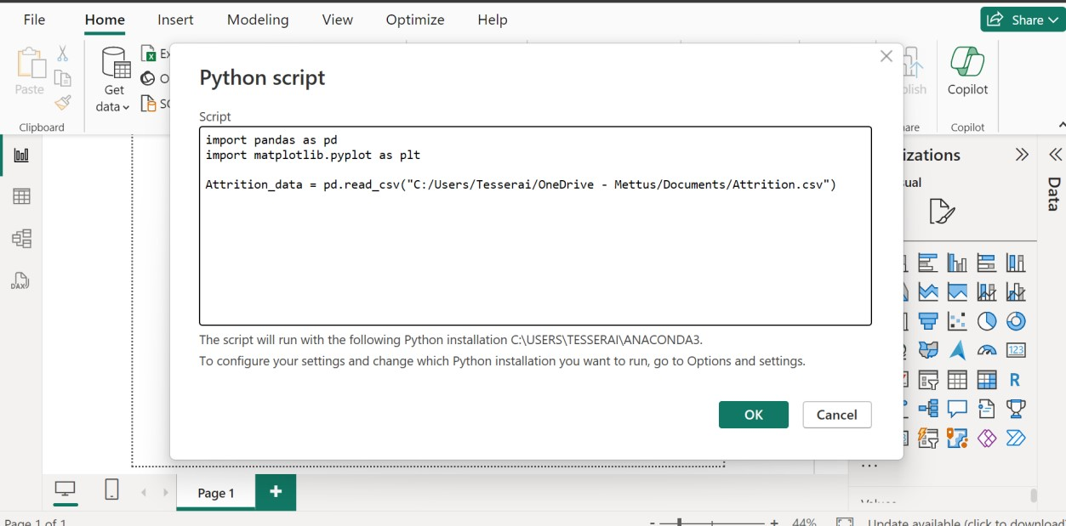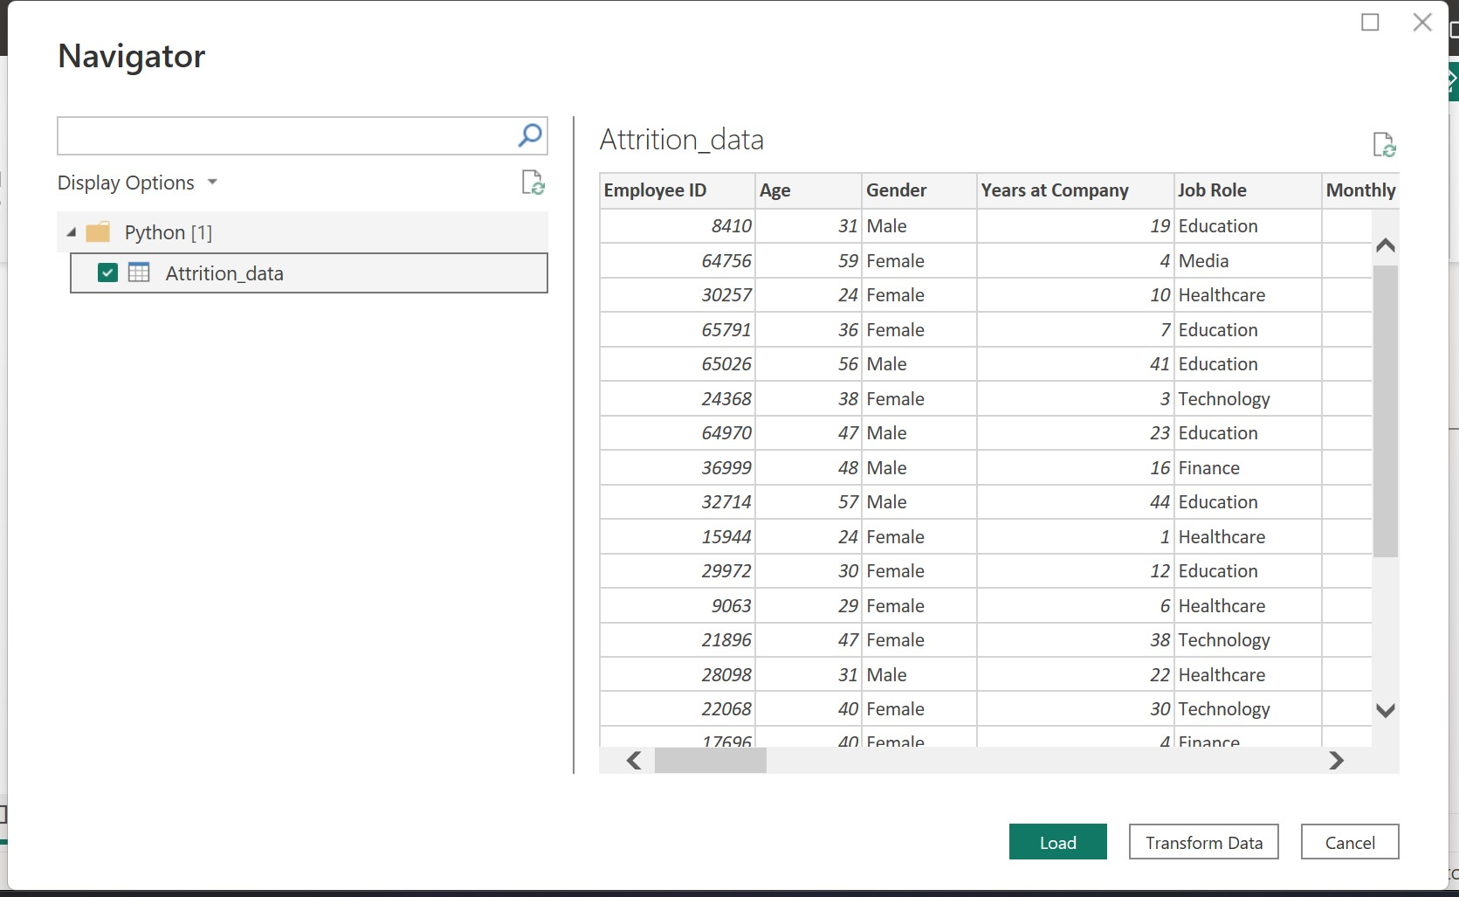

Transforming the Attrition data column from categorical to numerical:

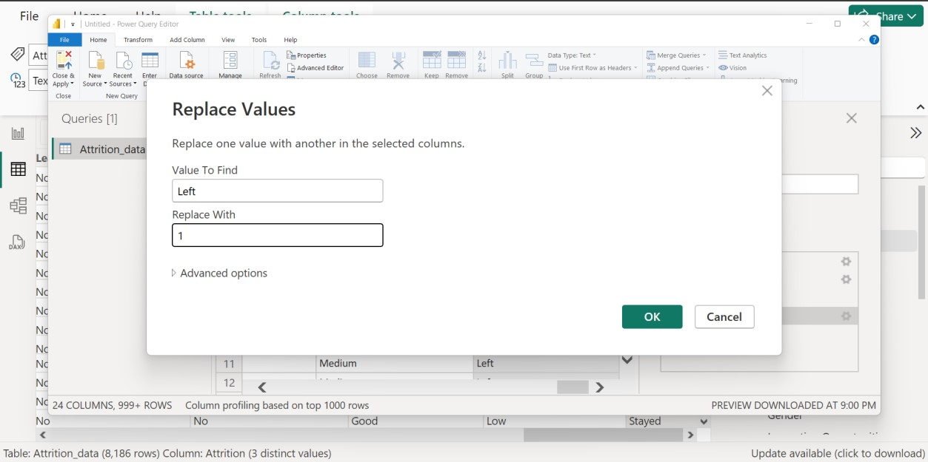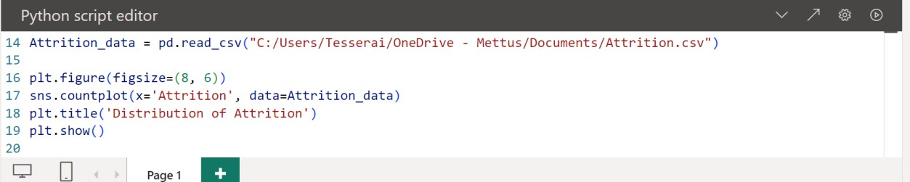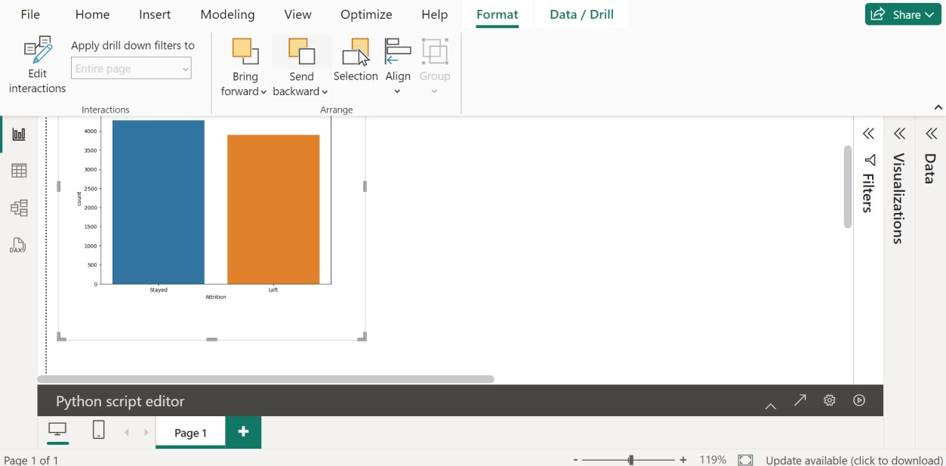

**More EDA Visuals**

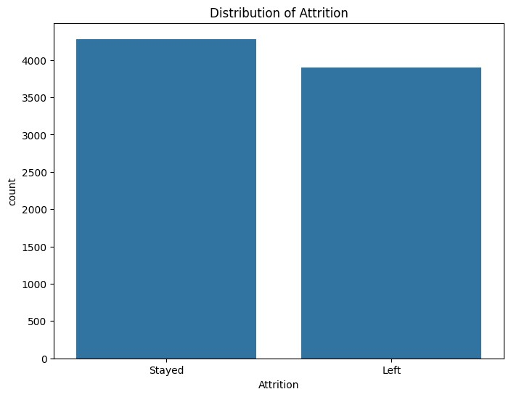

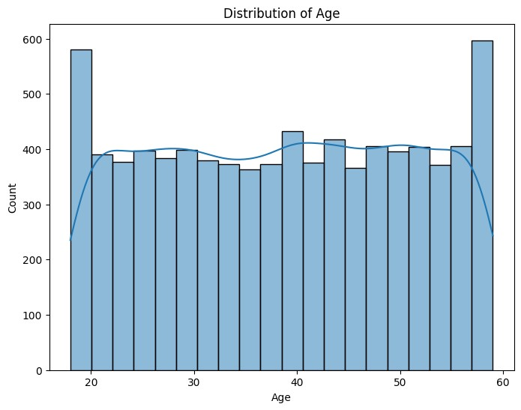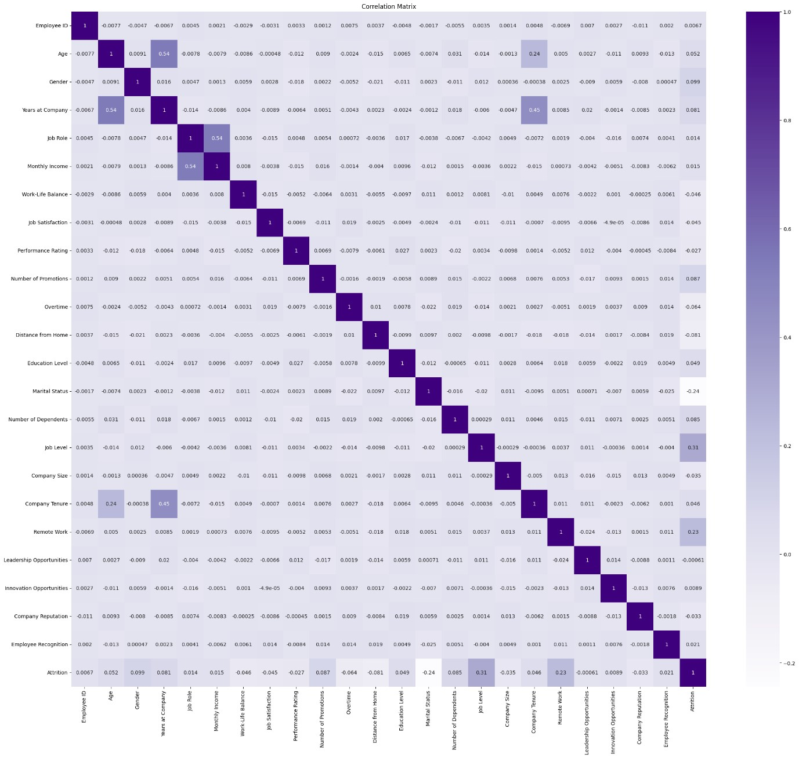

**Data Splitting**

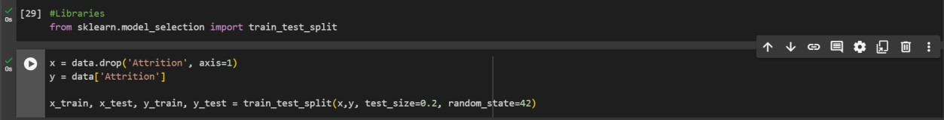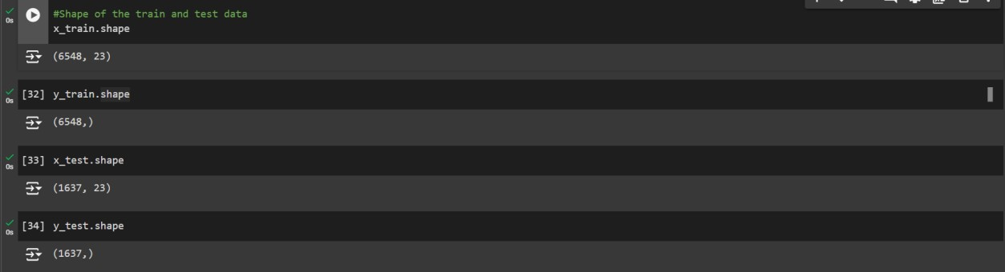

**Model Training**

The primary goal of the dataset is to classify employees into two categories: those who stayed and those who left the company. Logistic regression is specifically designed for binary classification tasks, making it ideal for distinguishing between these two outcomes. It estimates the probability that an employee falls into one of the two categories

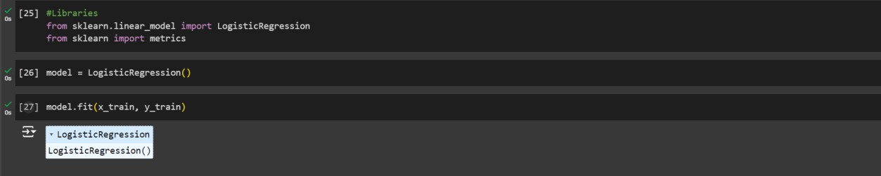

**Model Evaluation**

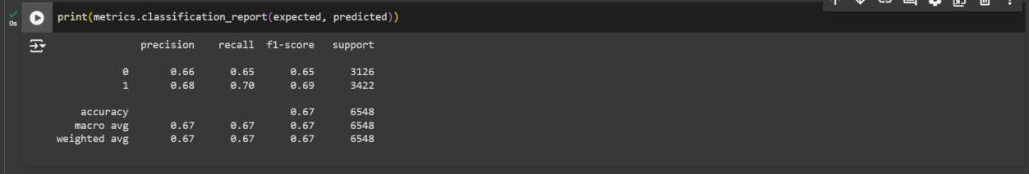

From the above metrics snippets, the model shows a balanced performance in classifying between the two classes. For the ‘0’, the precision is 66% and the recall is 65%, indicating a moderate performance in identifying the ‘0’ class. The ‘1’ class, however, there is a better performance in detecting this class, with a precision and recall of 68% and 70%, respectively. From this, it can be observed that the model has more difficulty predicting the stayed class compared to the left class.

**Amazon Web Service**

**Creating an S3 Bucket:**

An Amazon S3 bucket named ‘sagemakerteebucket’ is created to store the datasets and model files used in the project. The configuration is set to general purpose, which is recommended for most use cases and access patterns. This type of bucket allows for the distribution of storage across multiple availability zones, which ensures redundancy and reliability. The bucket is created in the US East N. Virginia) region. The bucket will be used for managing the input and output data for the AWS SageMaker model training and deployment process.

On the search bar in the aws console dashboard, search for S3:

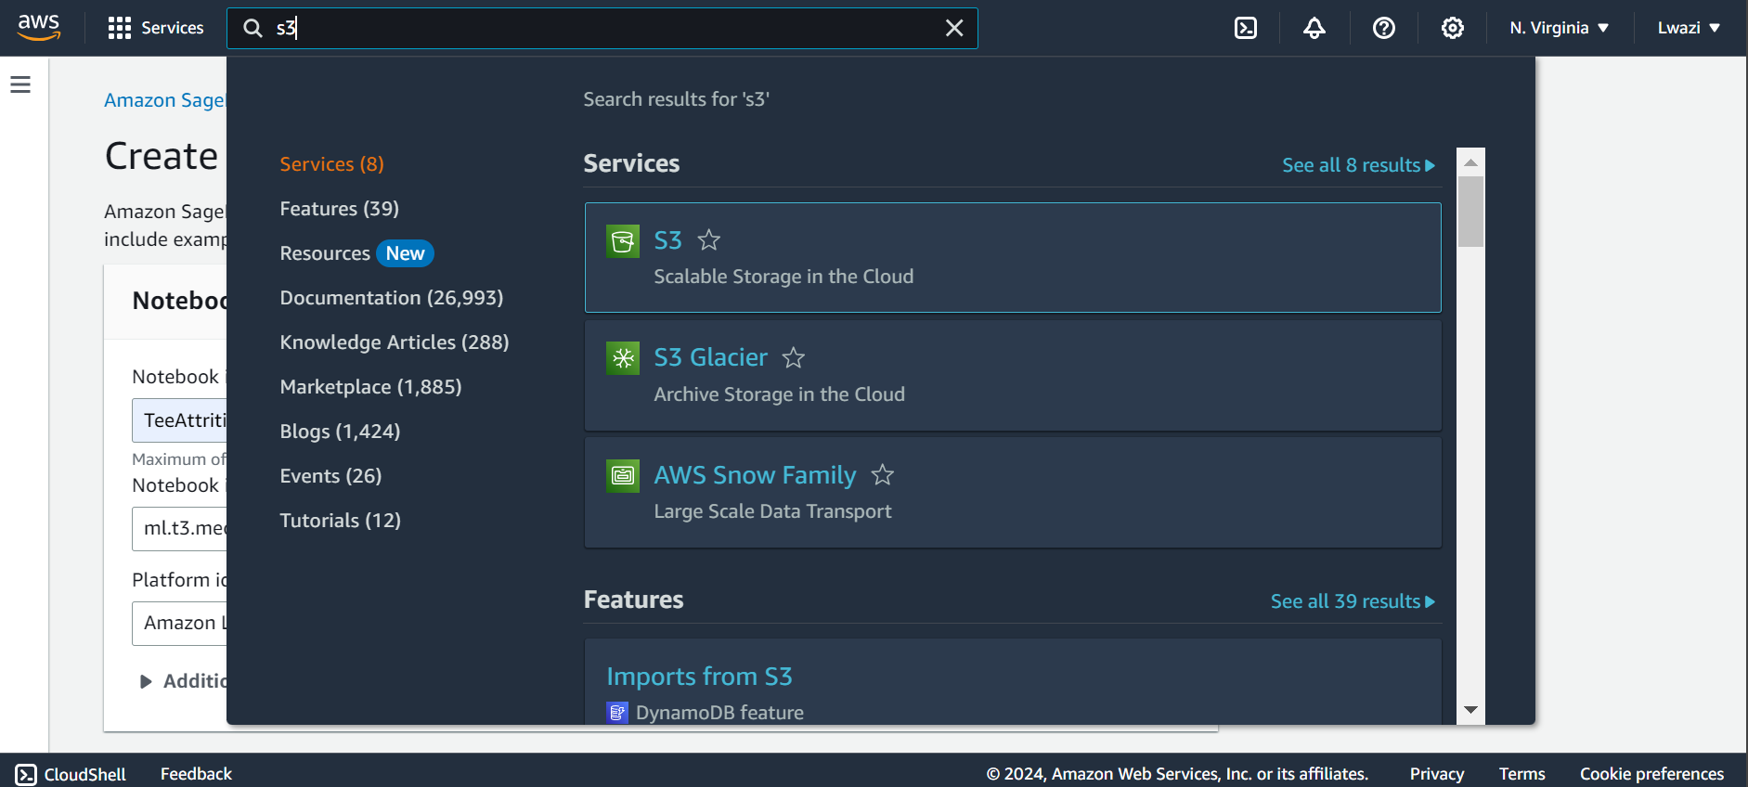

Create a new bucket: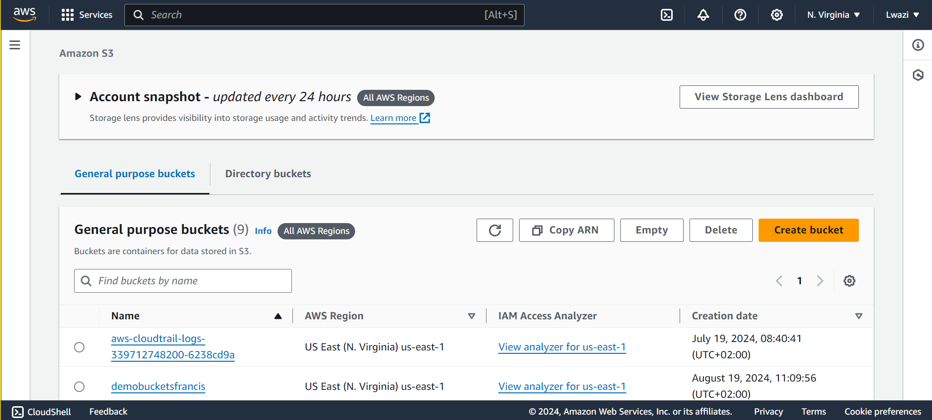 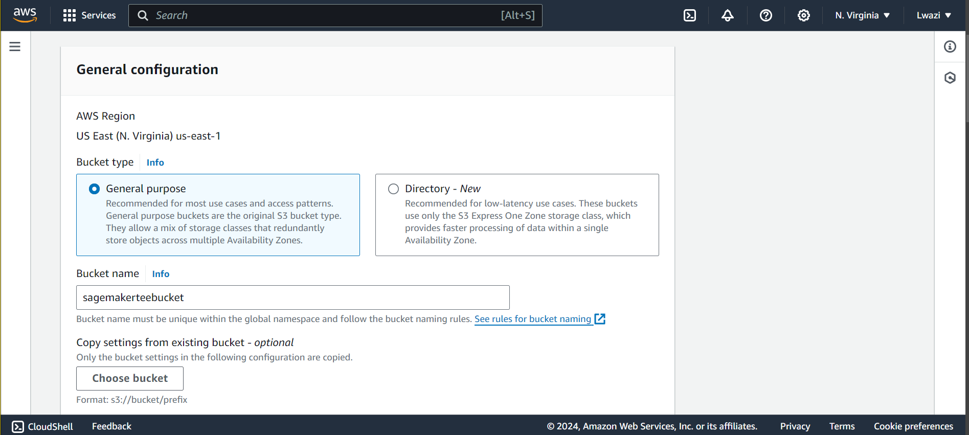 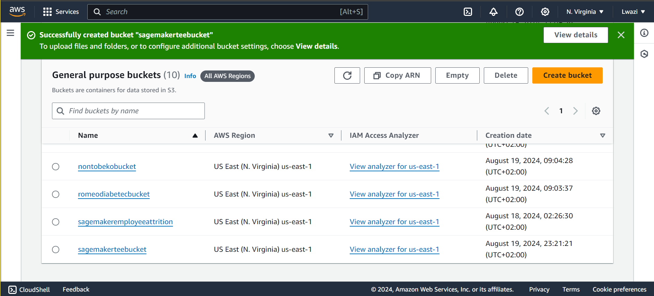

Amazon SageMaker

The following captures the process of setting up a new notebook instance in AWS SageMaker. The instance is named TeeAttrition and is configured to use the ‘ml.t3.medium’ instance type, which provides a balance of compute, memory and networking resources. This notebook instance is the environment where the model training and evaluation will be conducted.

On the search bar in the aws console dashboard, search for sagemaker:

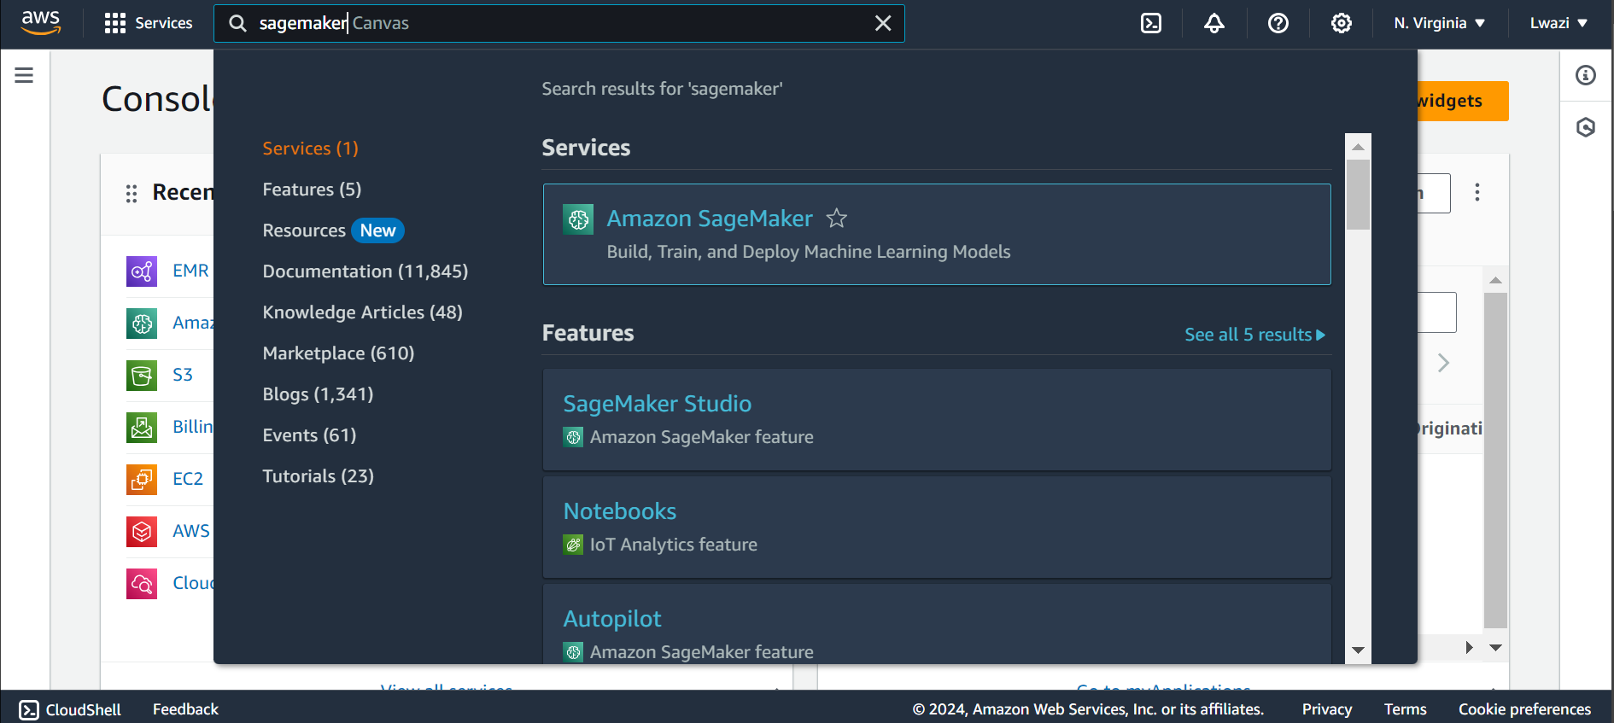

On the side bar, in the Amazon SageMaker dashboard, navigate to notebooks under Applications and IDEs:

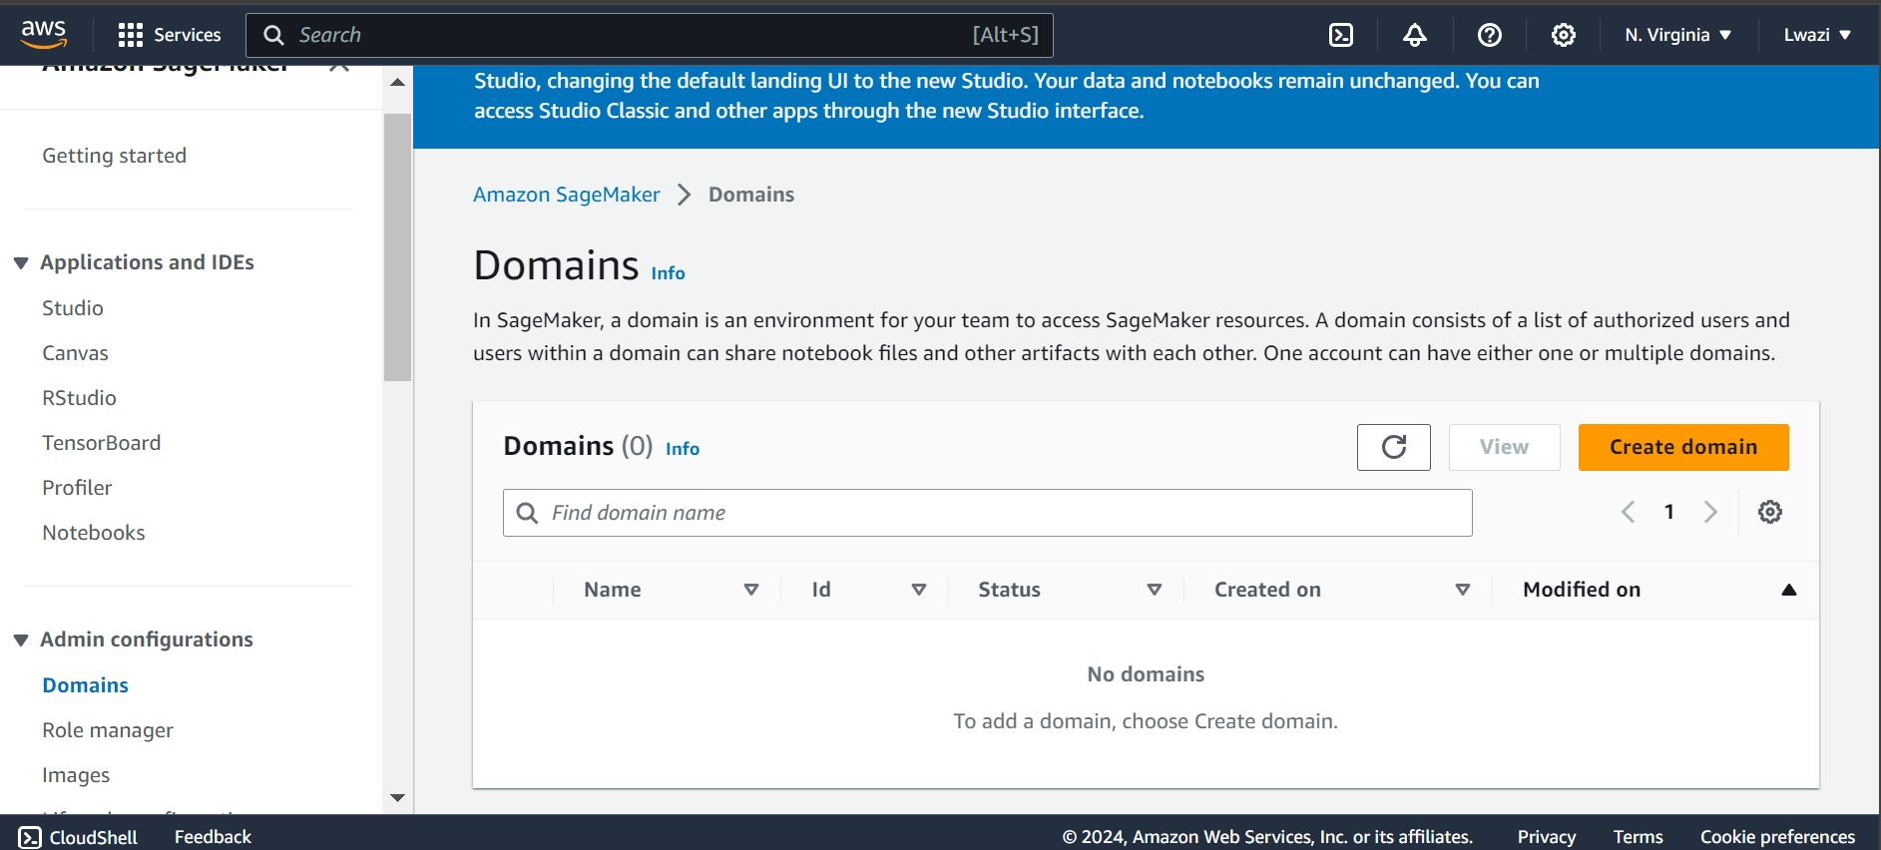

Create a notebook instance:

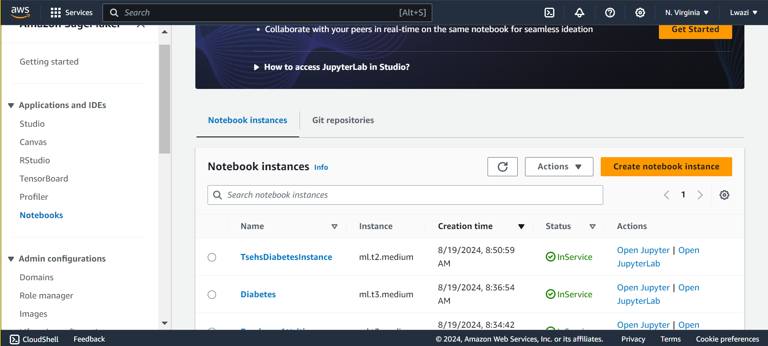 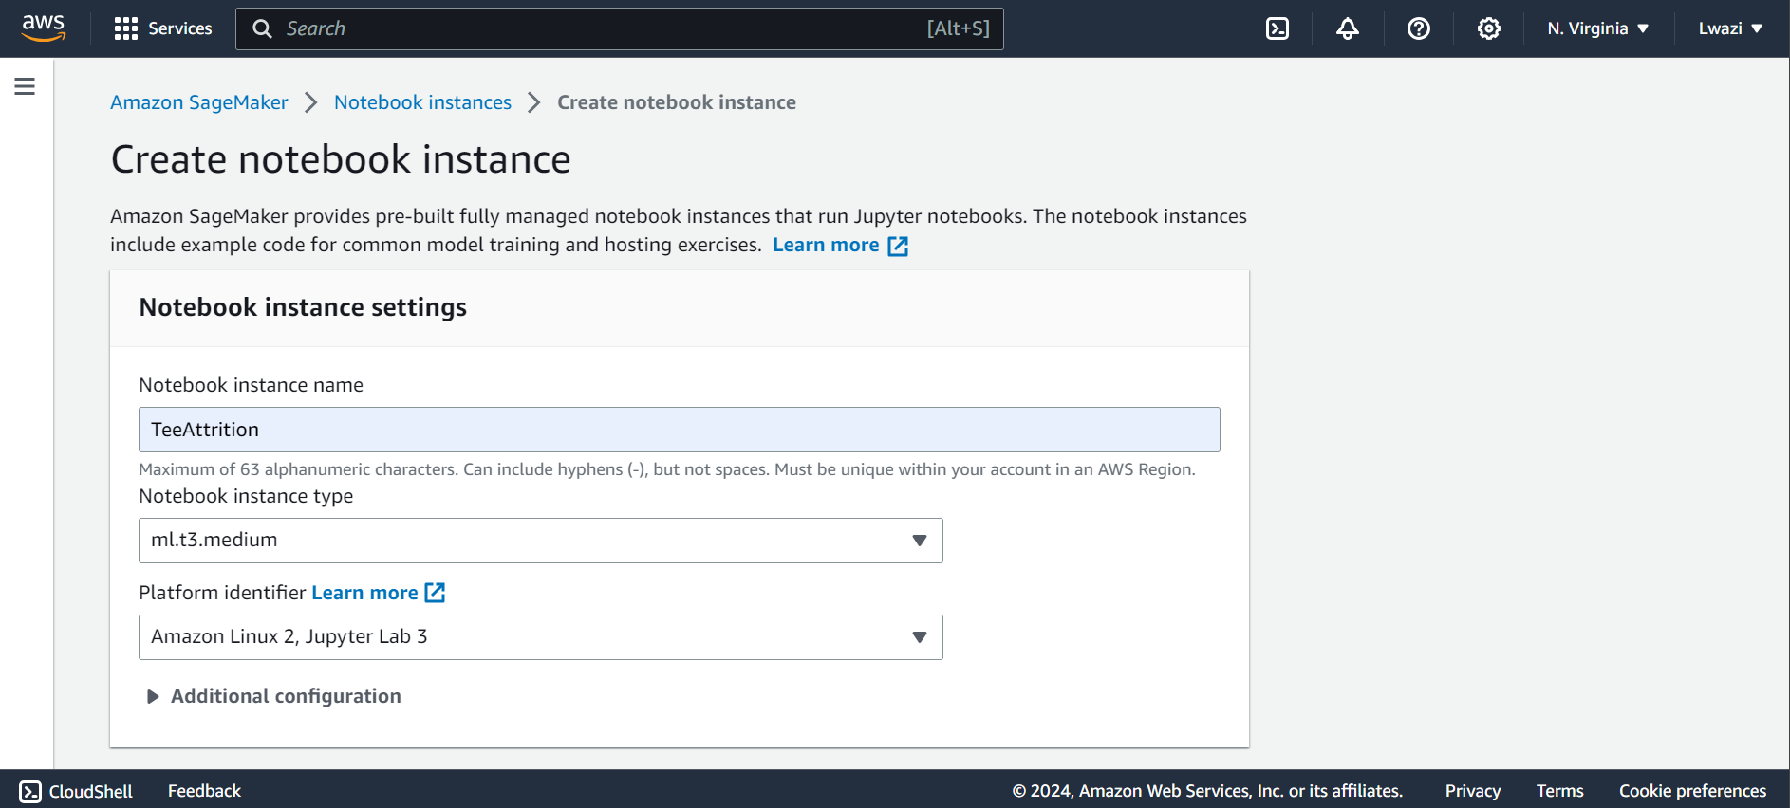

Creating an IAM role:

The IAM role allows the SageMaker notebook instance to access the selected S3 bucket. The role is restricted to a specific bucket, which ensures that the SageMaker instance can read and write only to the designated storage loaction. This is important for handling input datasets and storing the model outputs.

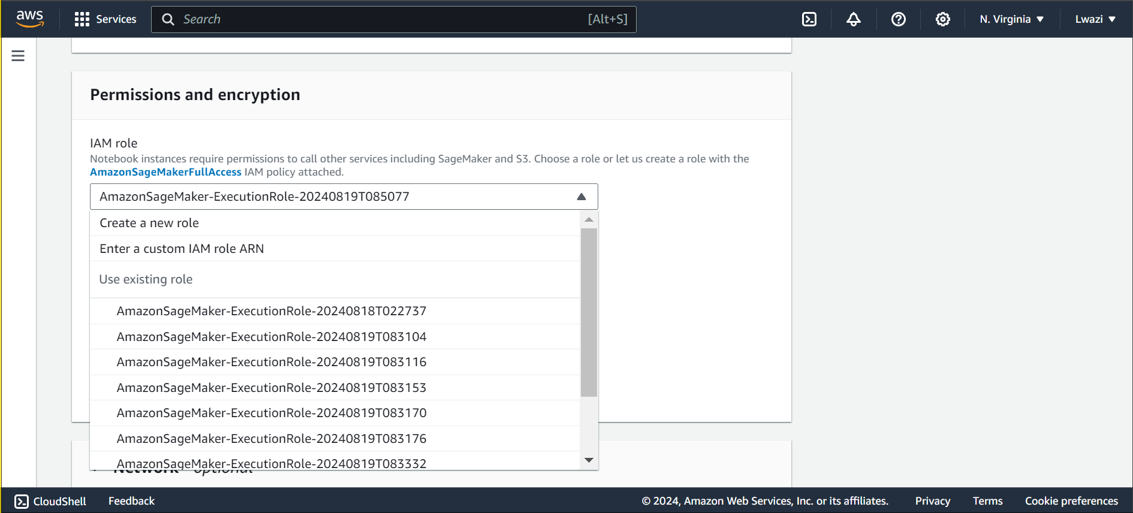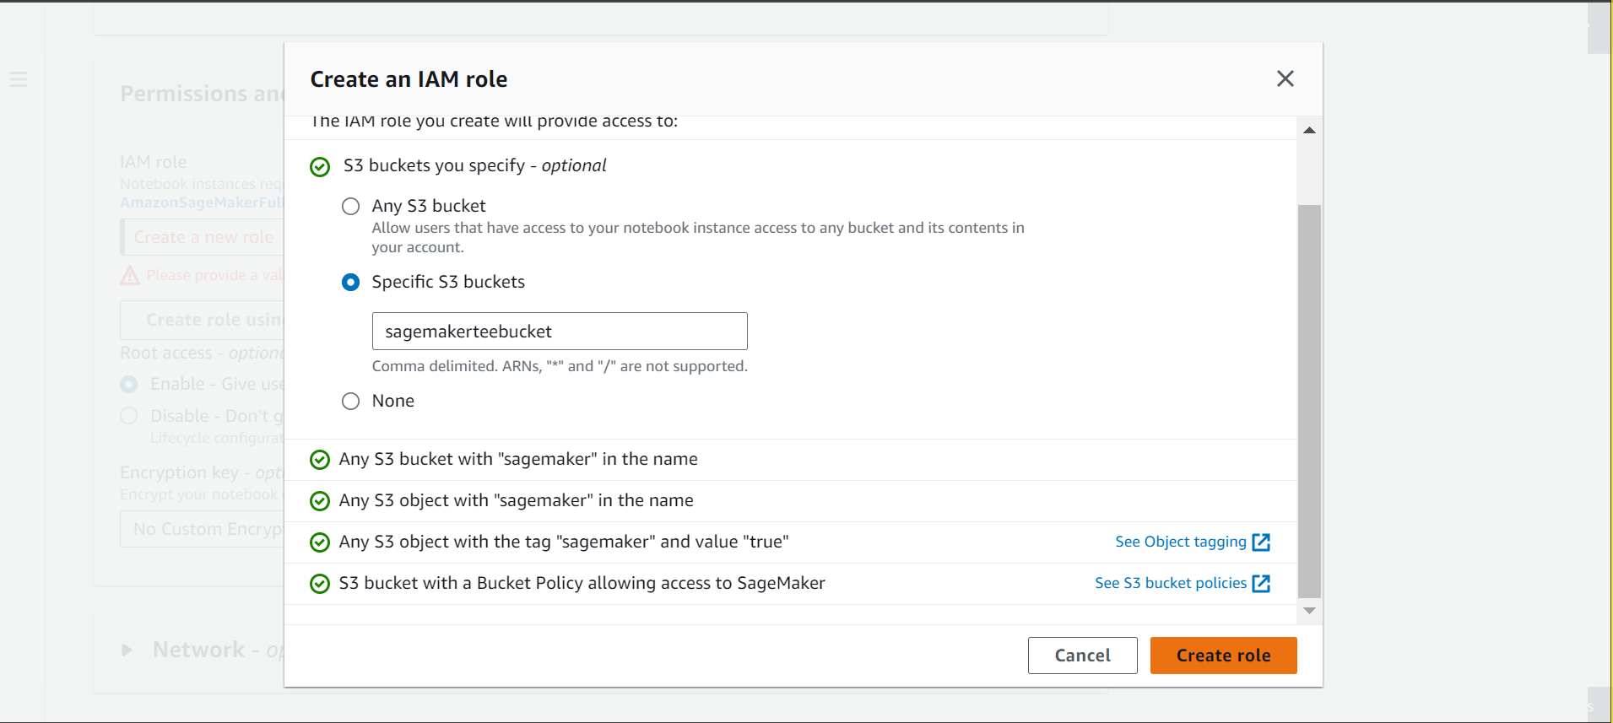 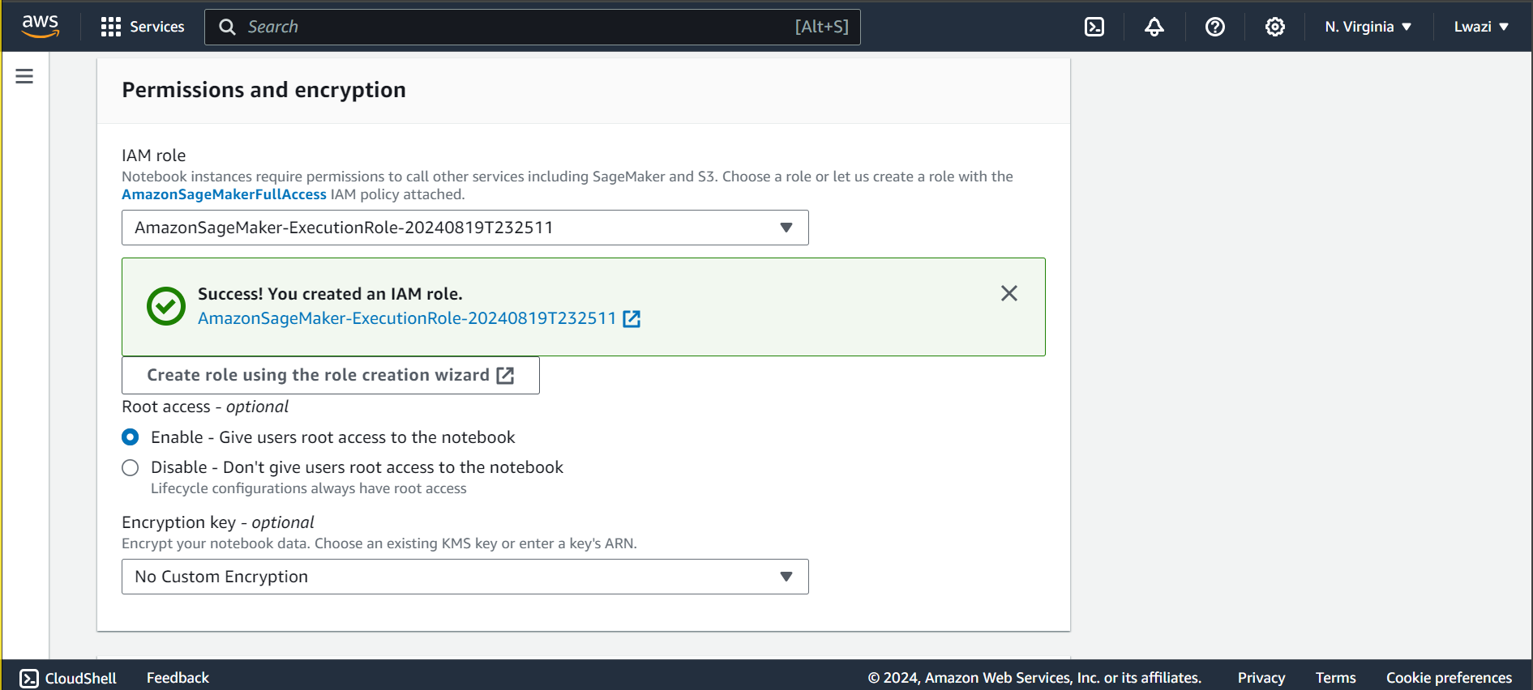 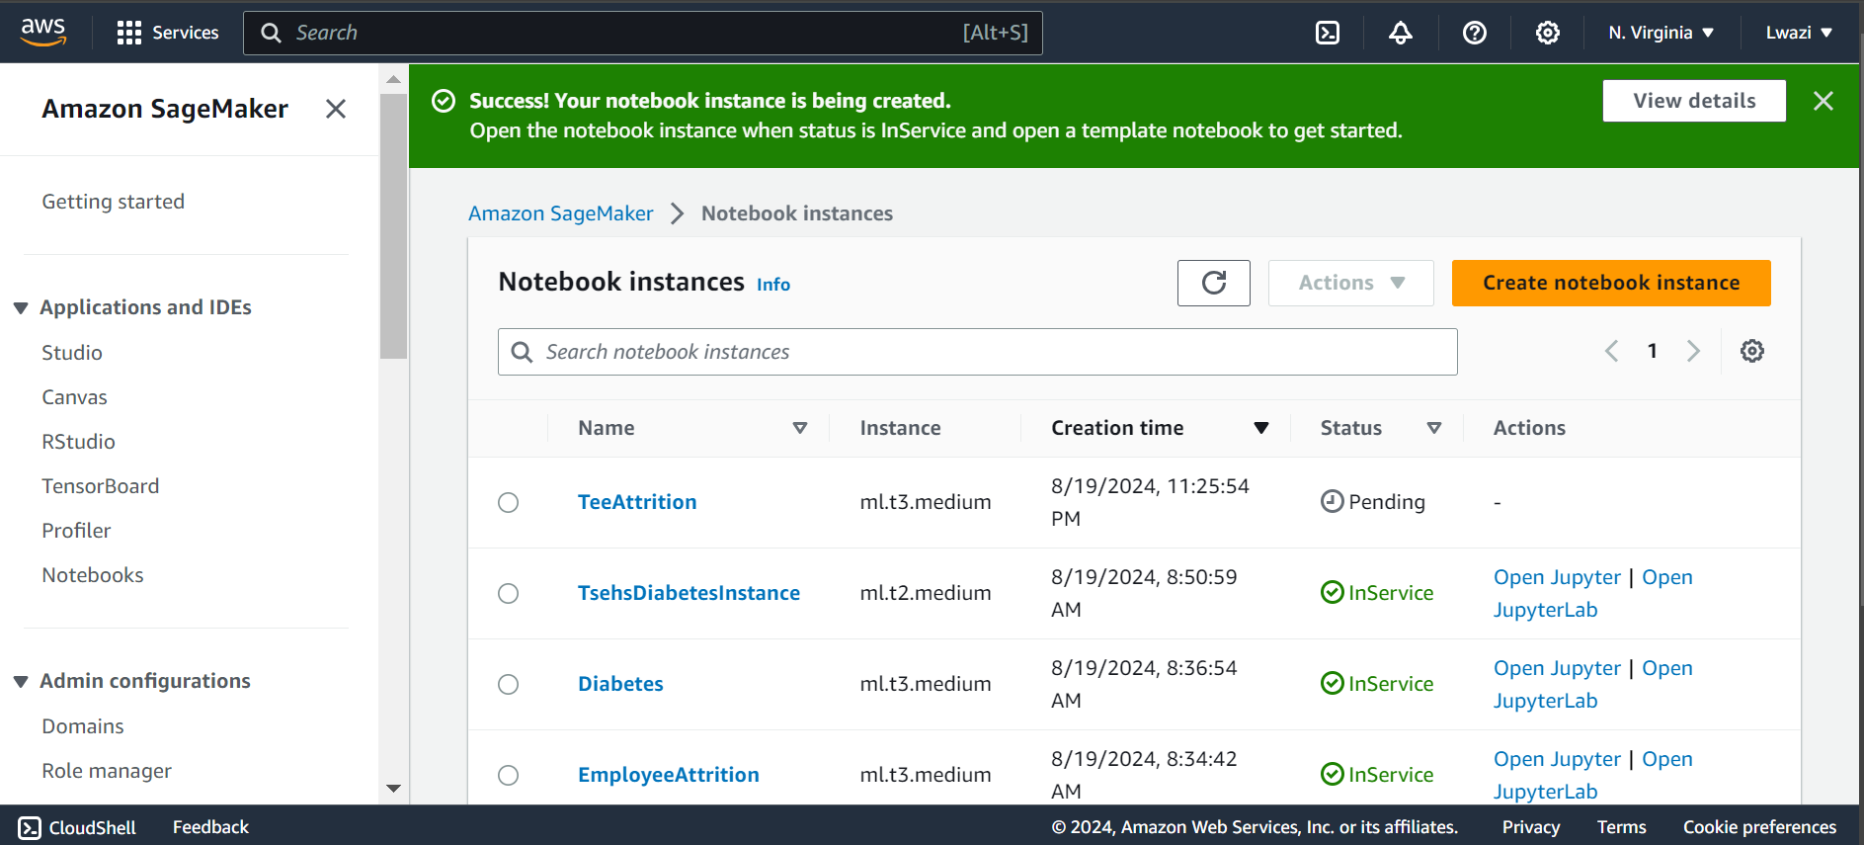

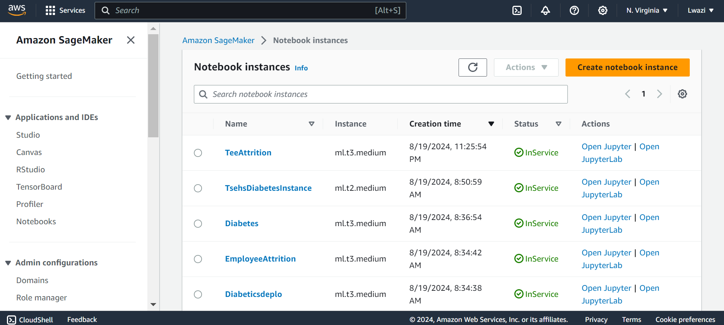

Uploading the attrition dataset together with the google colab notebook to be edited:

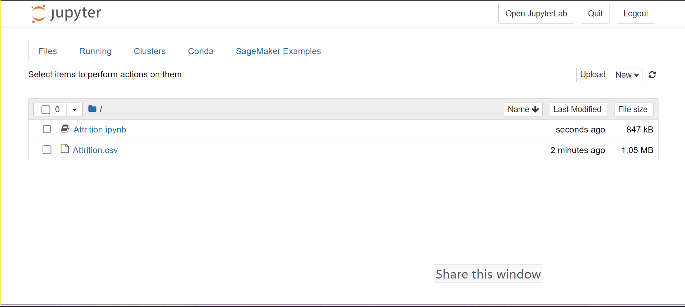

One can continuing from the data splitting portion of the project. The x and y, test and train data is combined, respectively, for better display. The are other modifications that were done in the following part of the project.

**Feature Engineering**

Label encoding the categorical data to prepare it for further analysis.

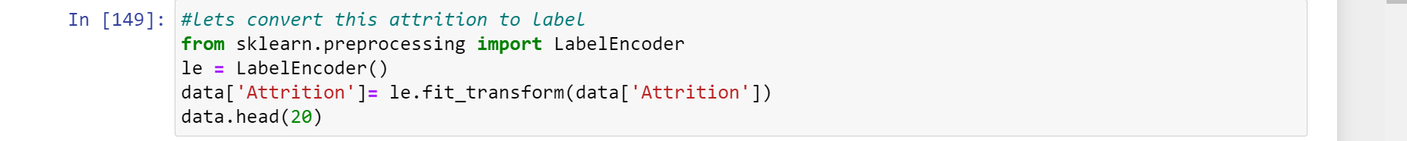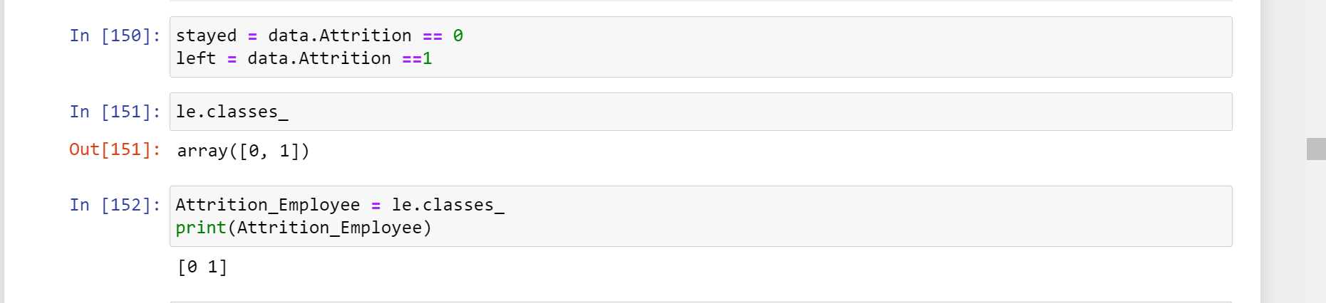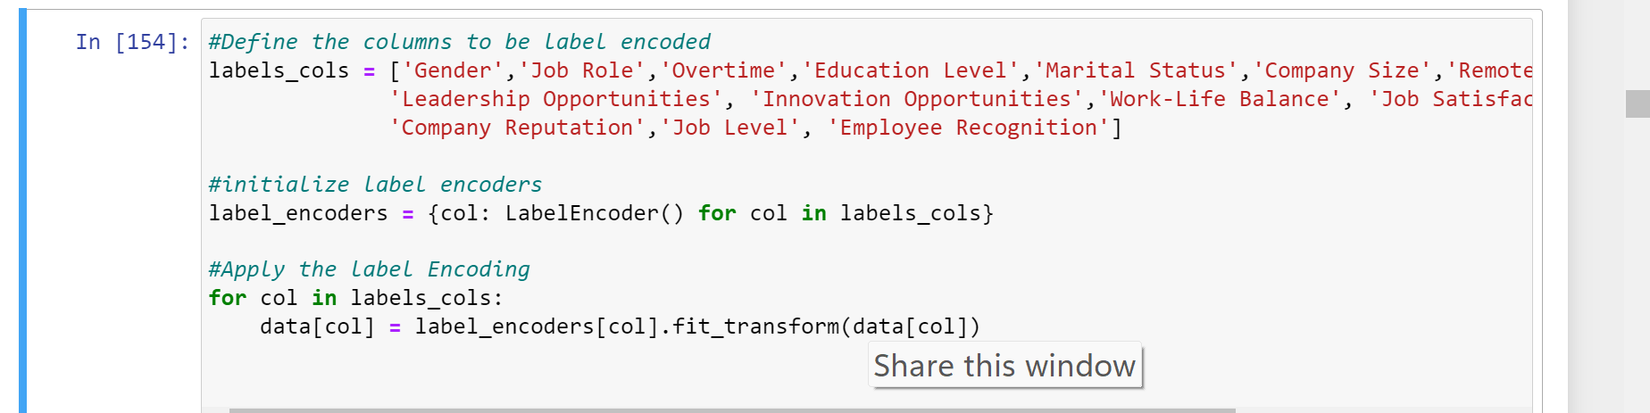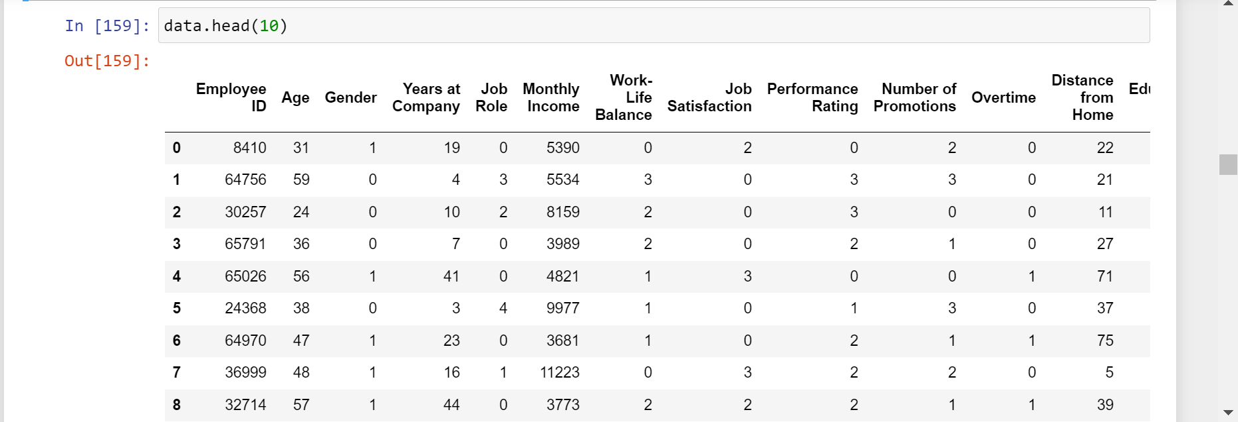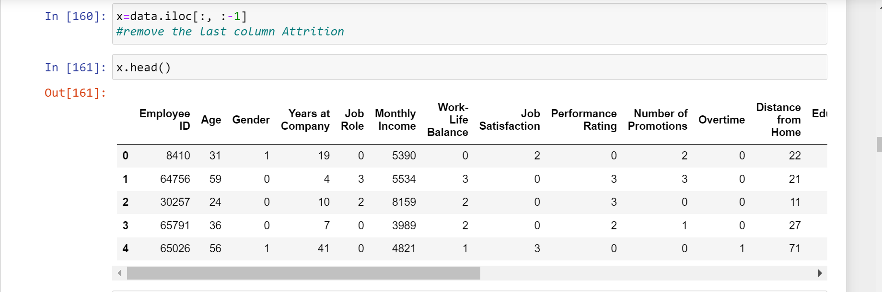

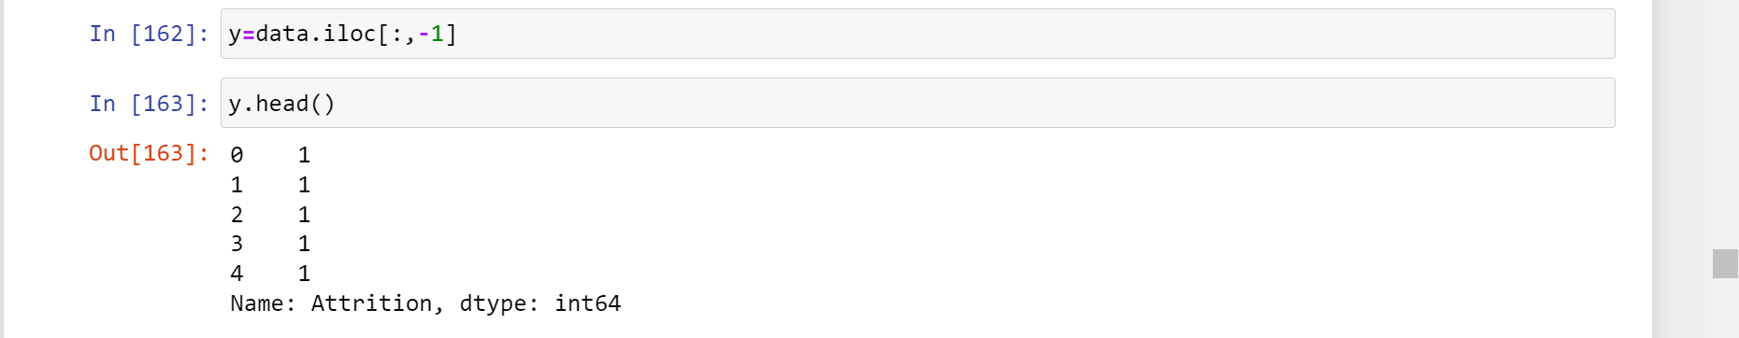

**Data Splitting**

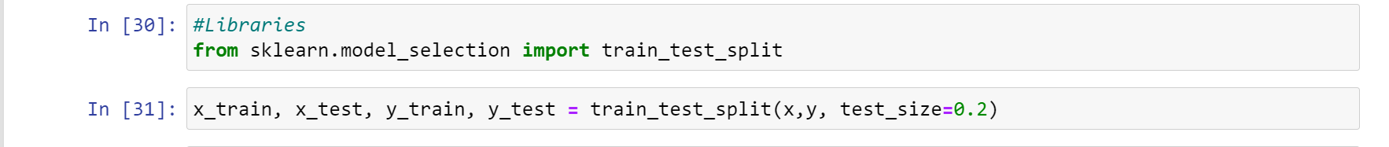

Saving the Files: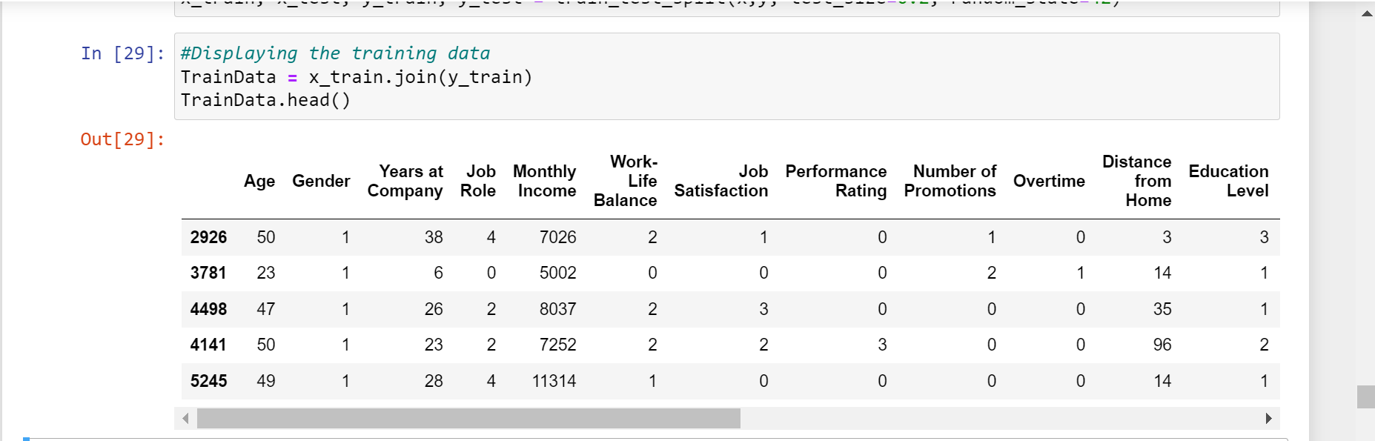 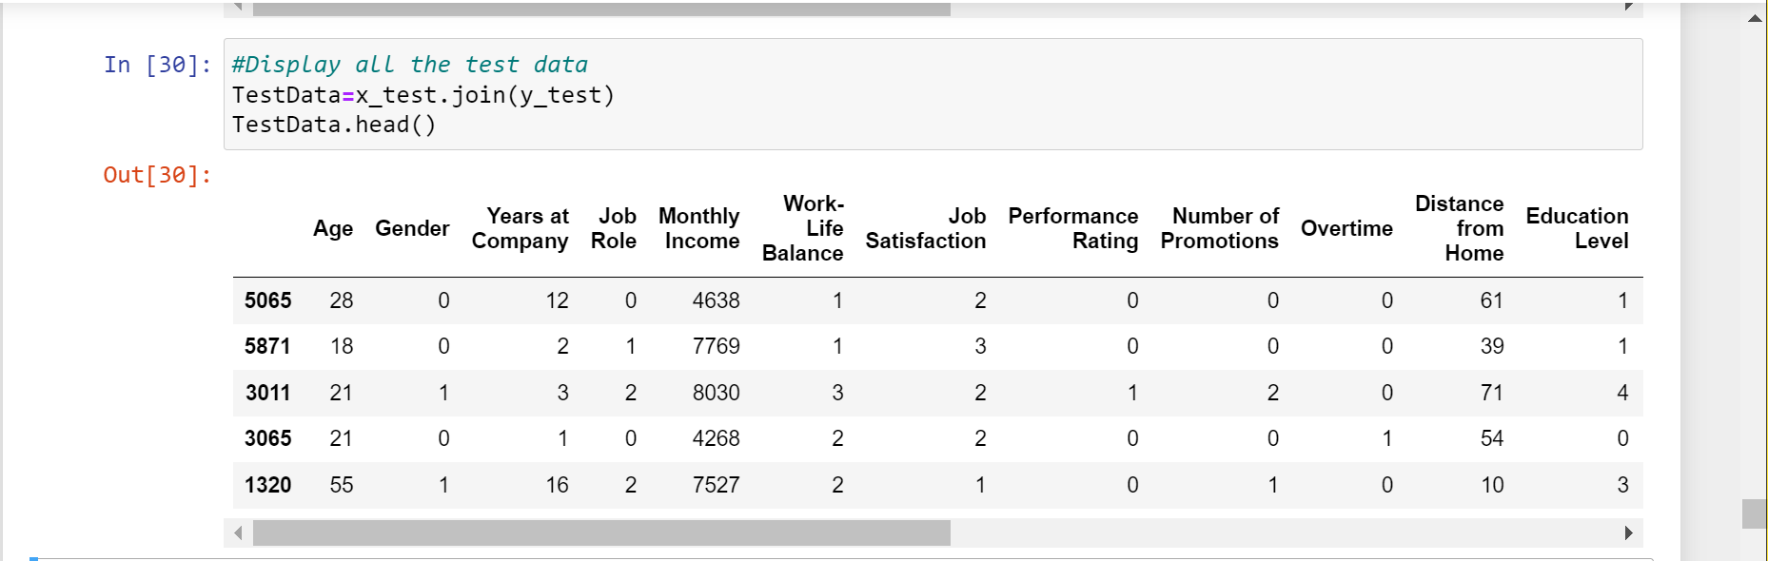 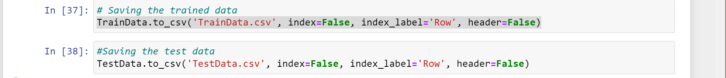 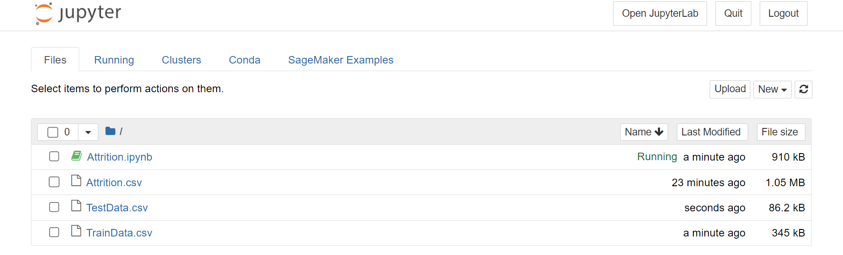The saved data can be seen on the notebook home list.

From there, the boto3 library is used to upload the files to the S3 bucket. The paths to the training and testing datasets are defined, their S3 paths are constructed, then they are uploaded to the to the designated S3 bucket loactions.

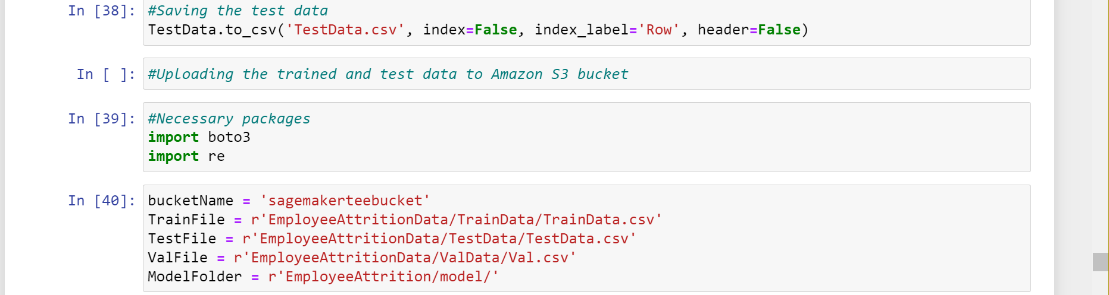 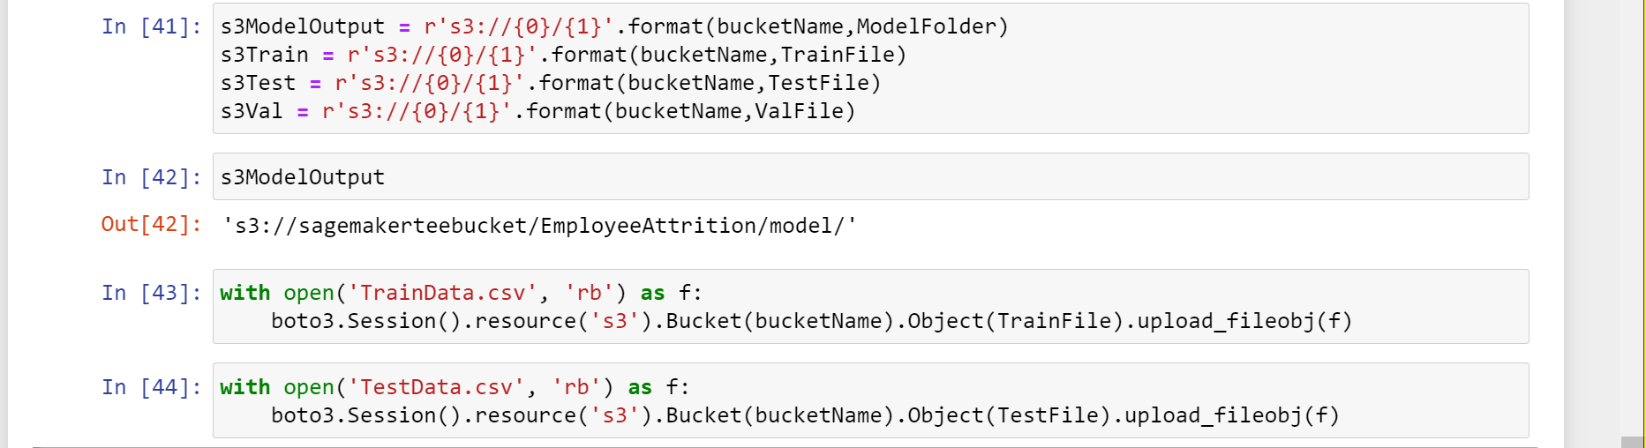

From the following snippets, it can be observed that the folders and datasets, have indeed been uploaded on the specified S3 bucket.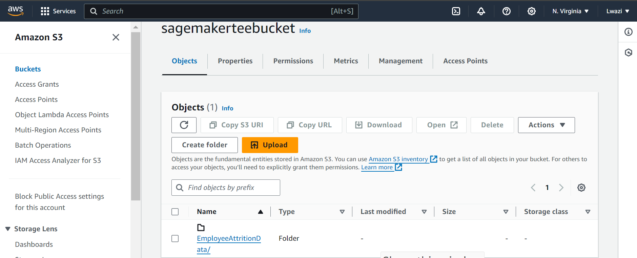 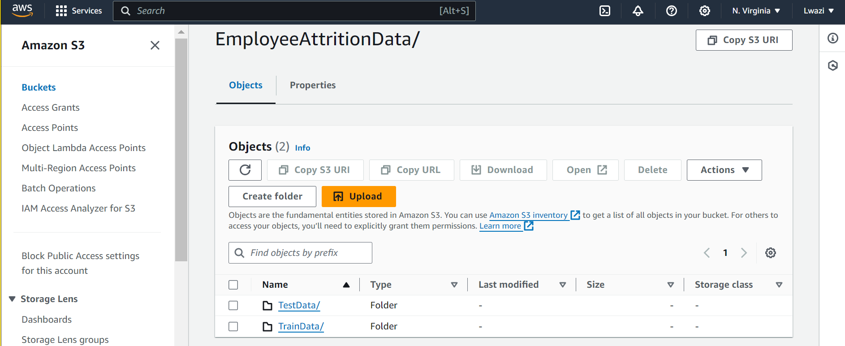 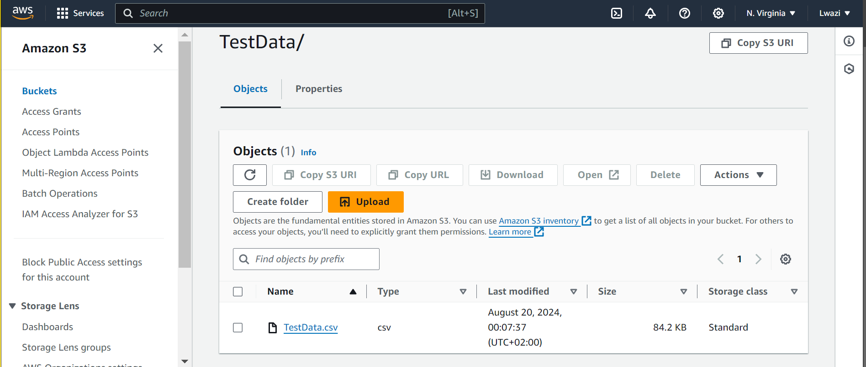 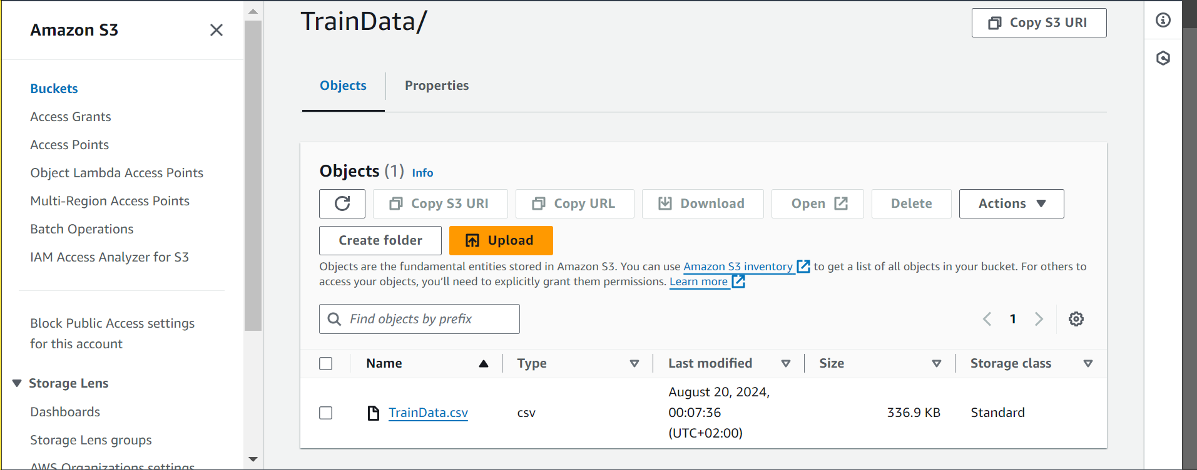

**Model Building and Training**

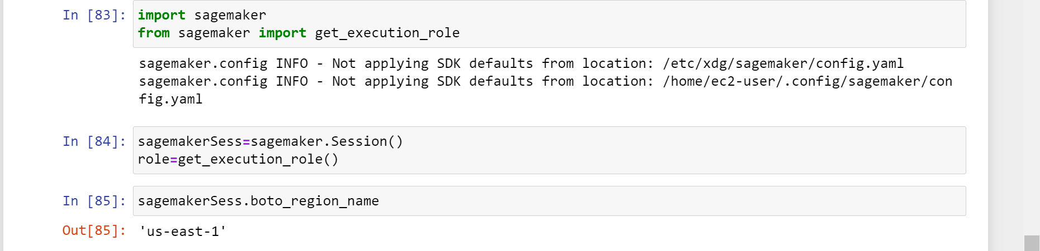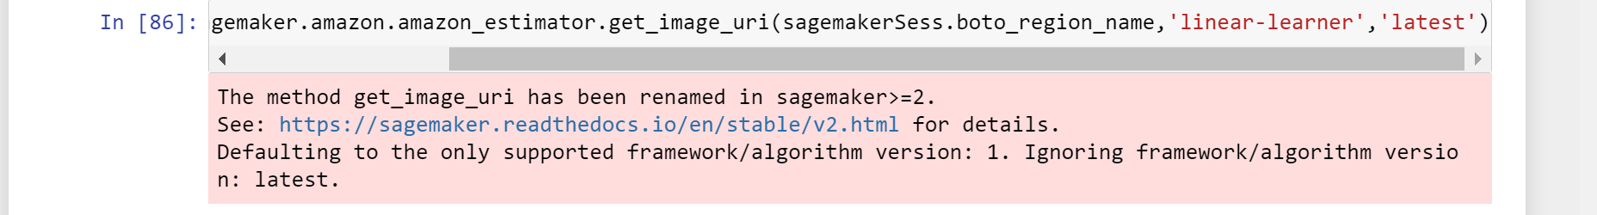

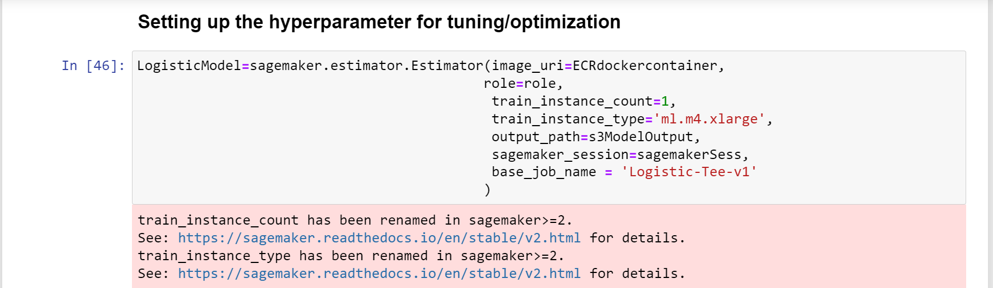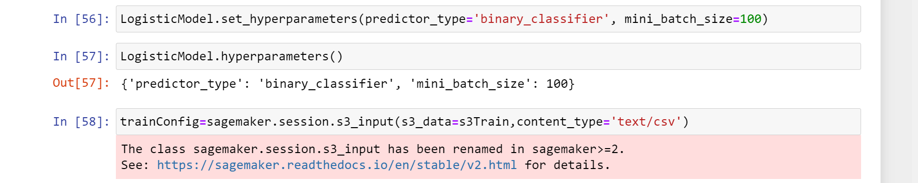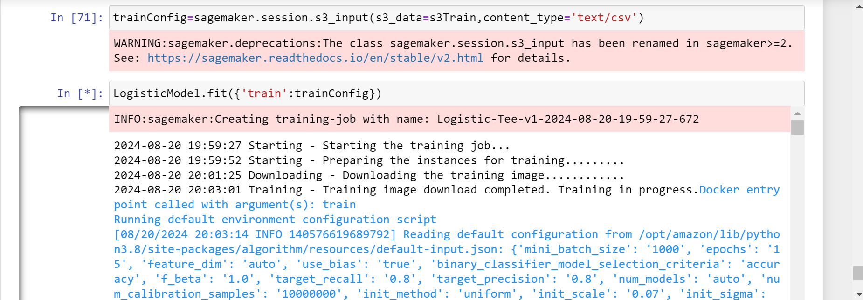 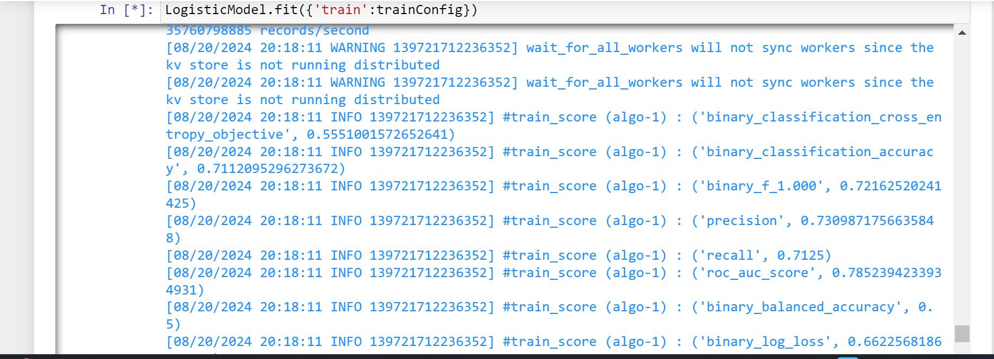 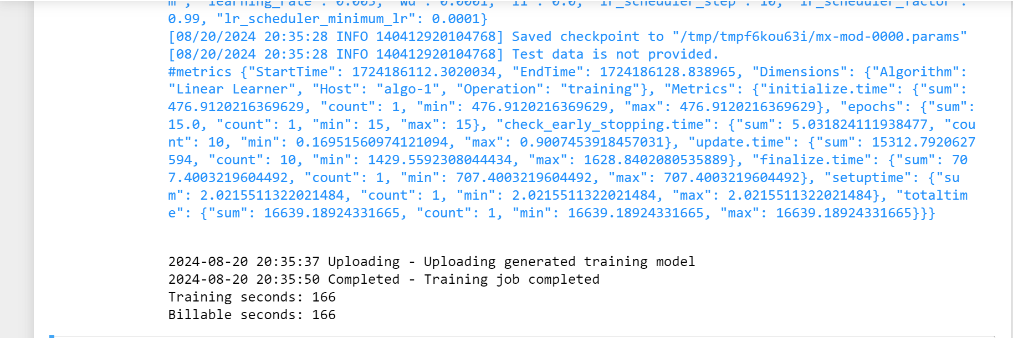

Much improved model evaluations due to the hyperparameters. 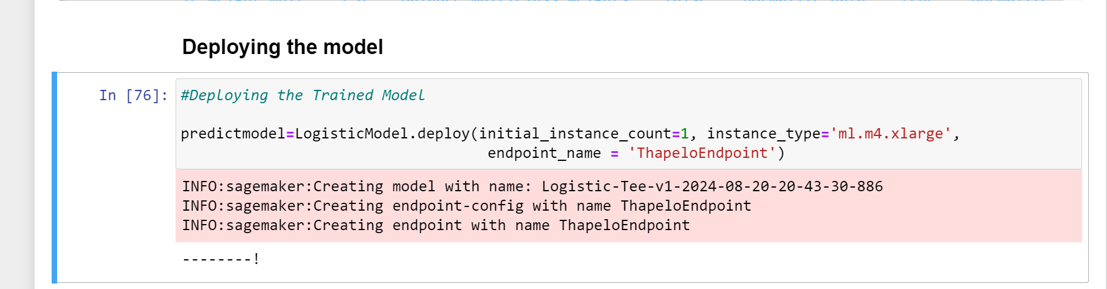

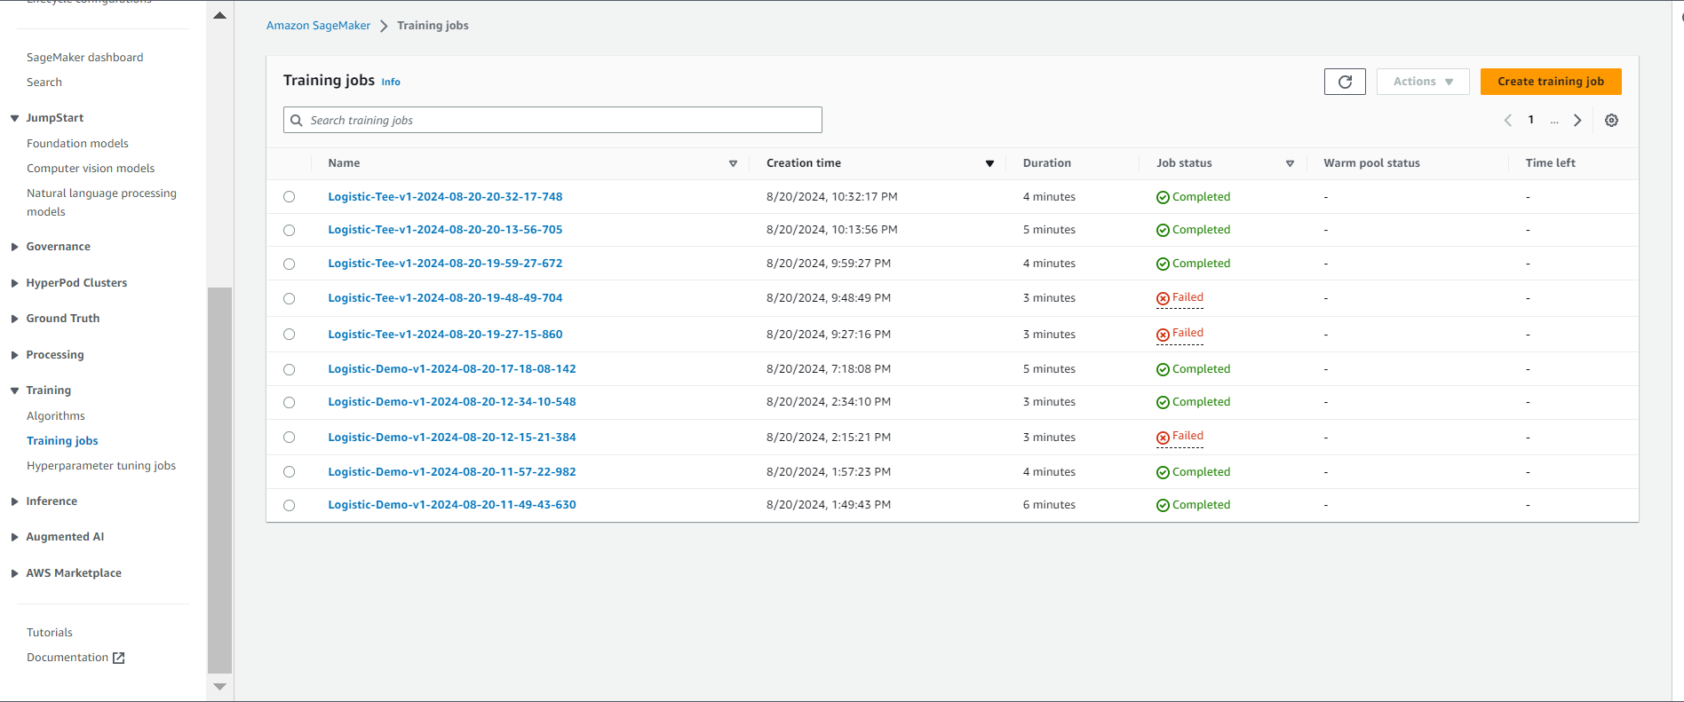

**Endpoints:** 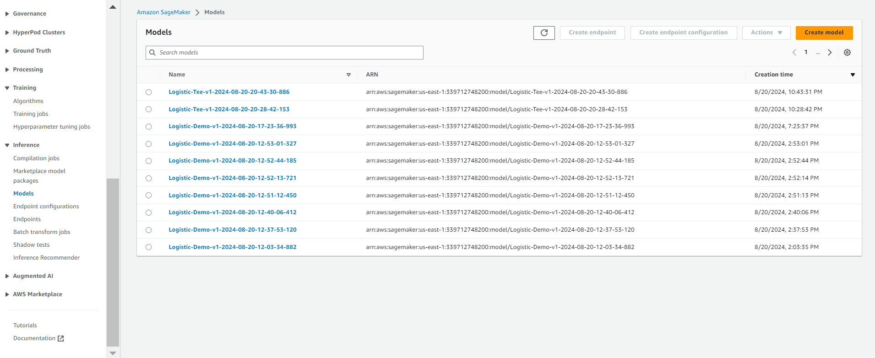 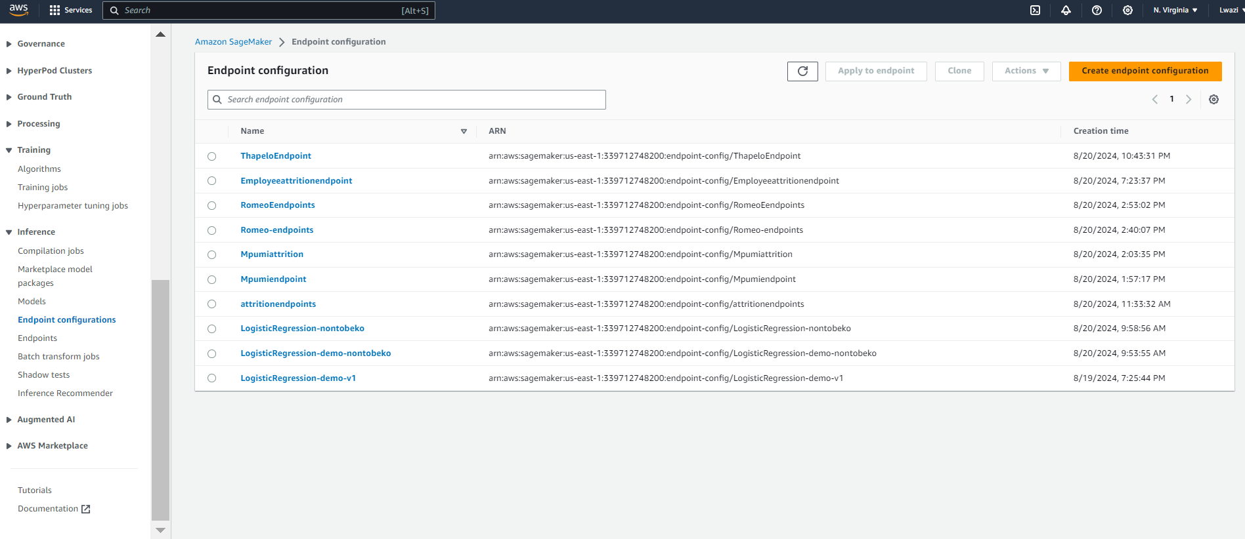 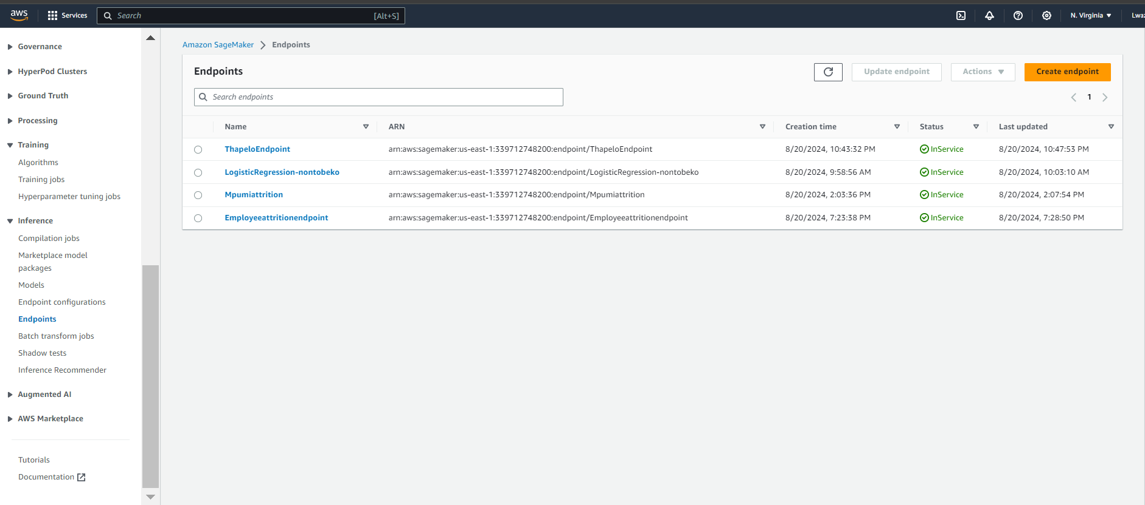 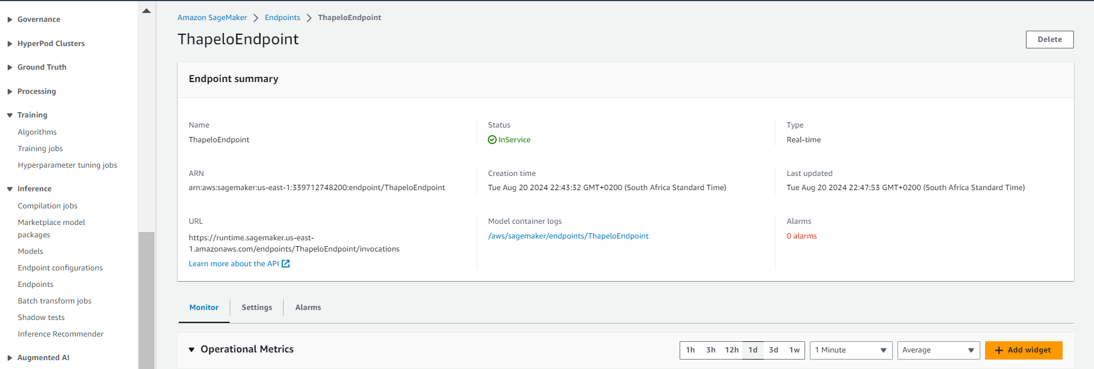 **Endpoint URL**

https://runtime.sagemaker.us-east-1.amazonaws.com/endpoints/ThapeloEndpoint/invocations

**Monitoring**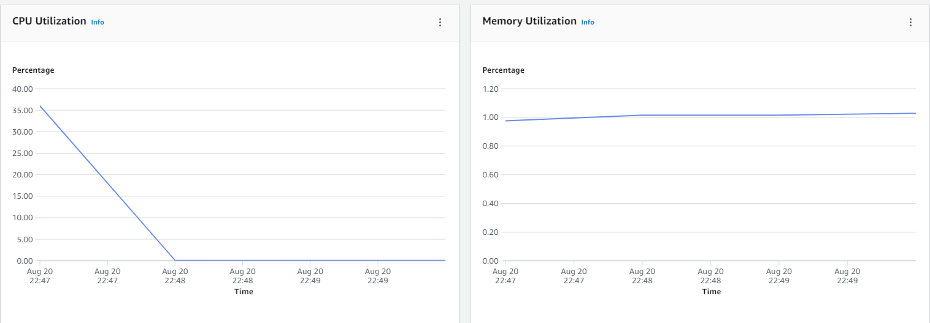 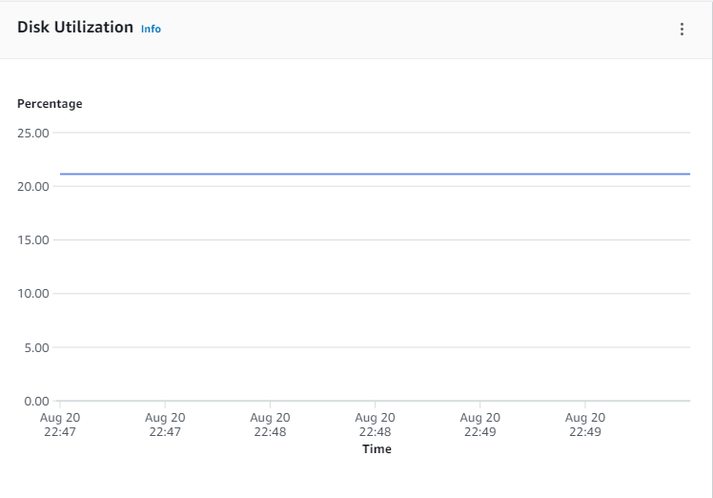 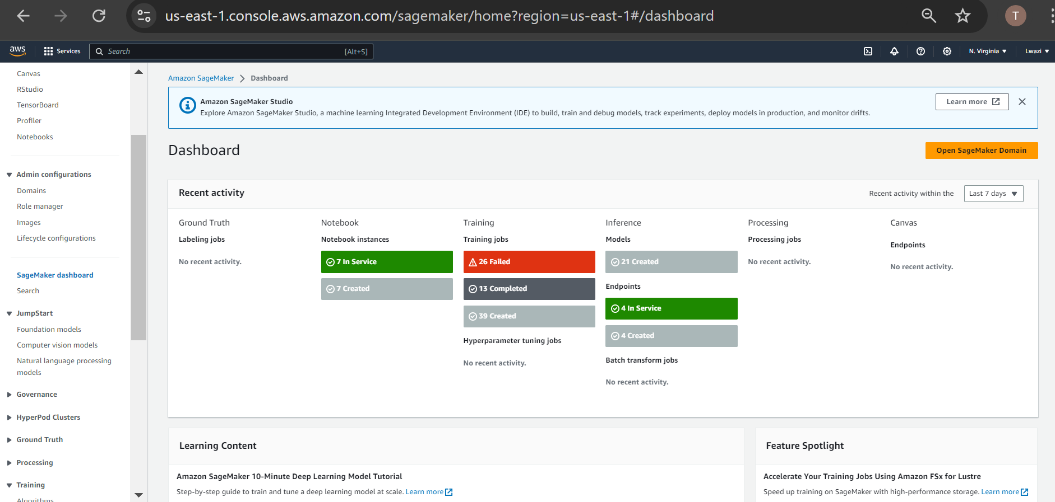

**Consuming and Testing**

Creating a Lambda Function:

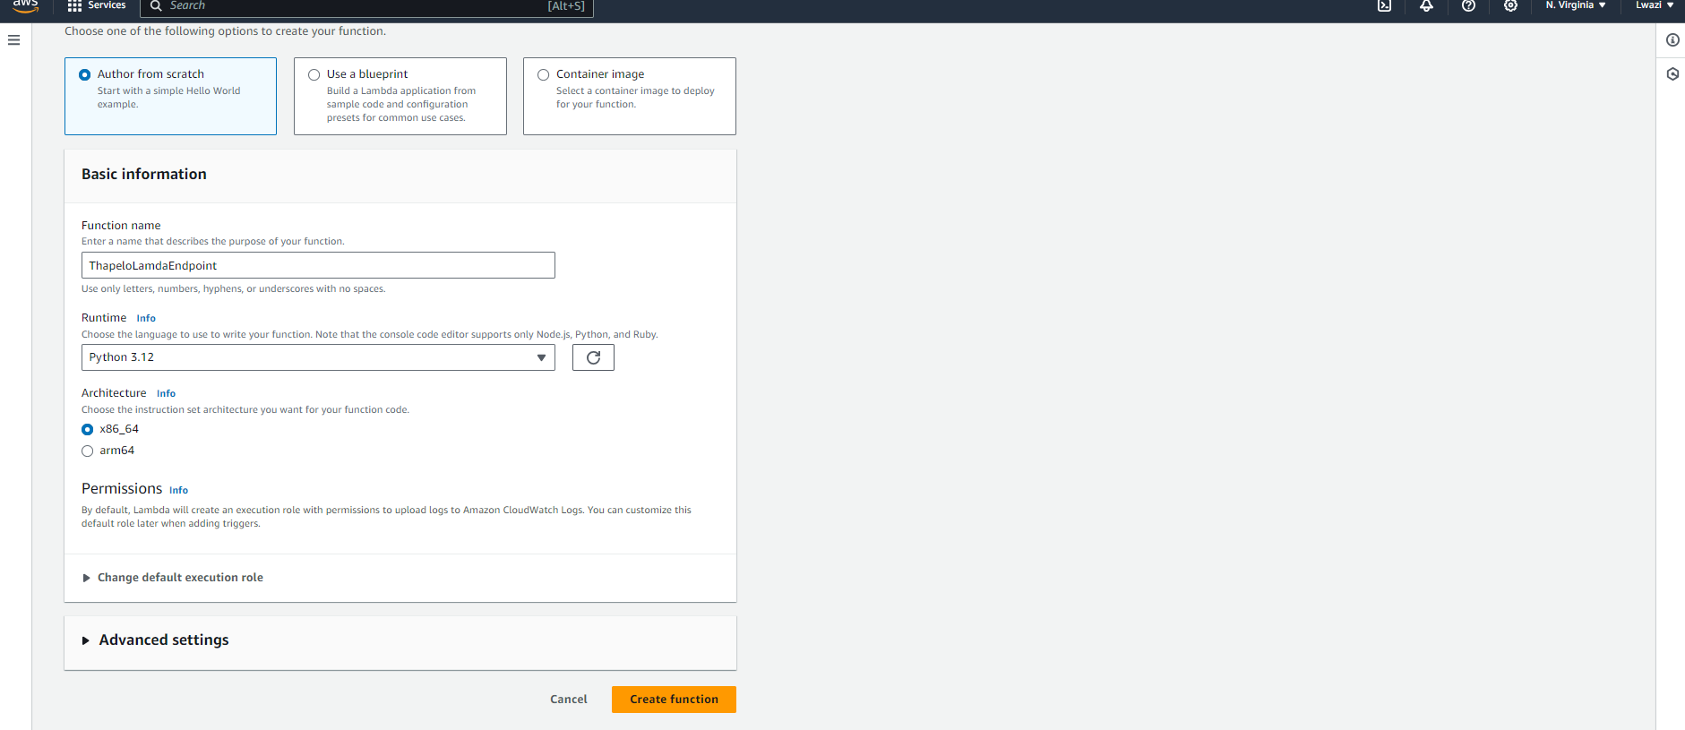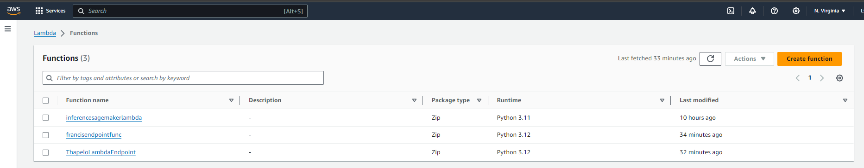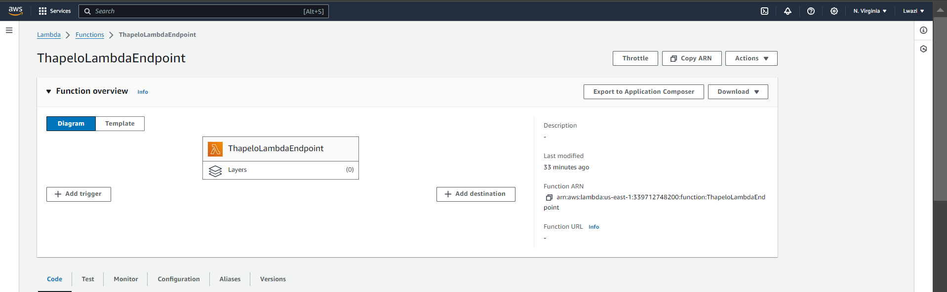

Code: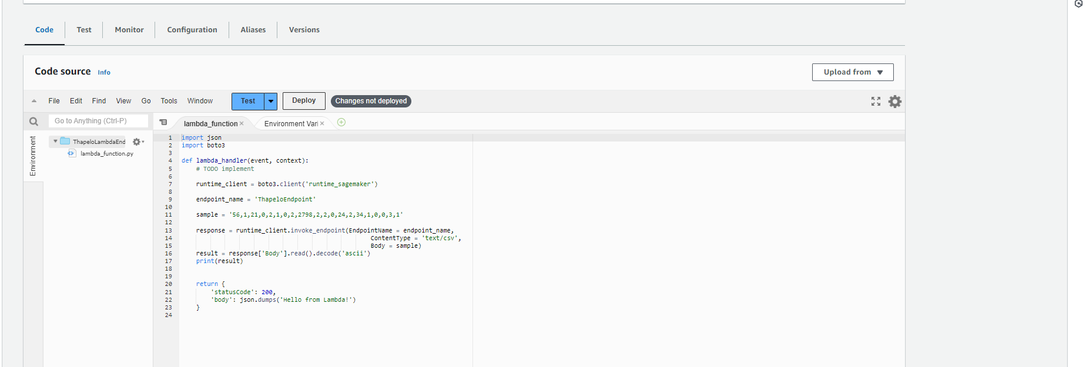

Configuration:

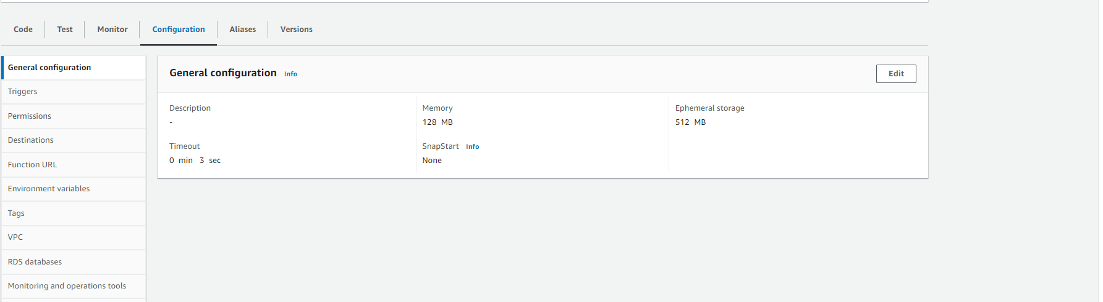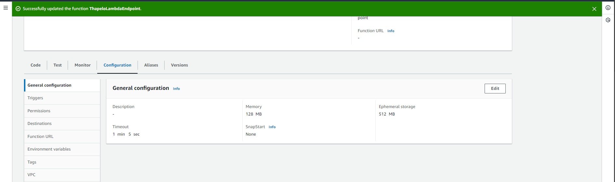

Create IAM role for basic lambda access and sagemaker access:

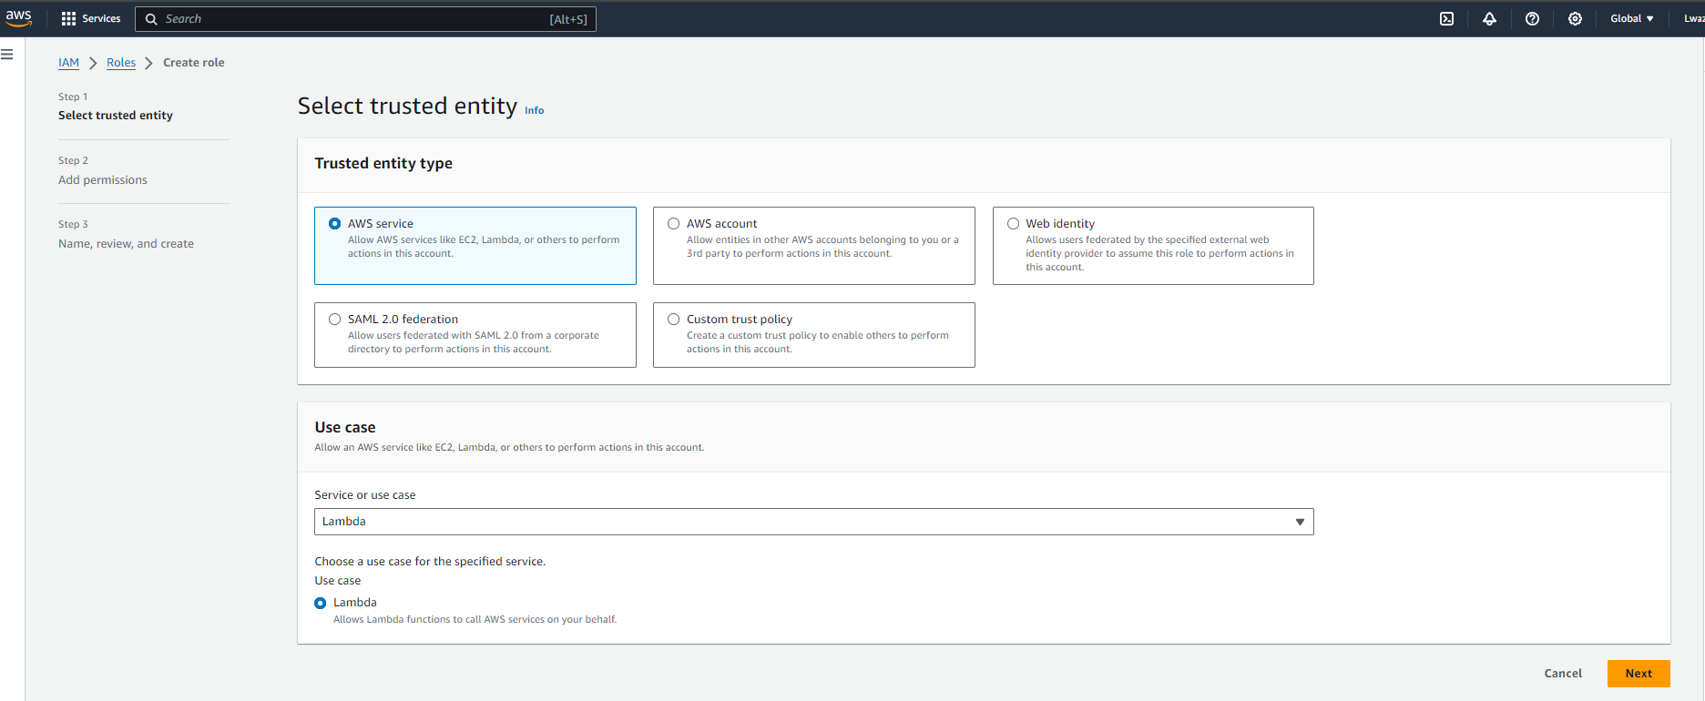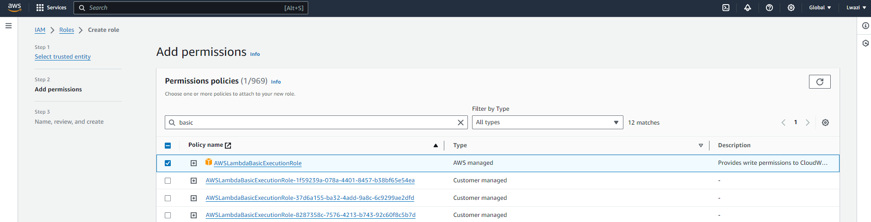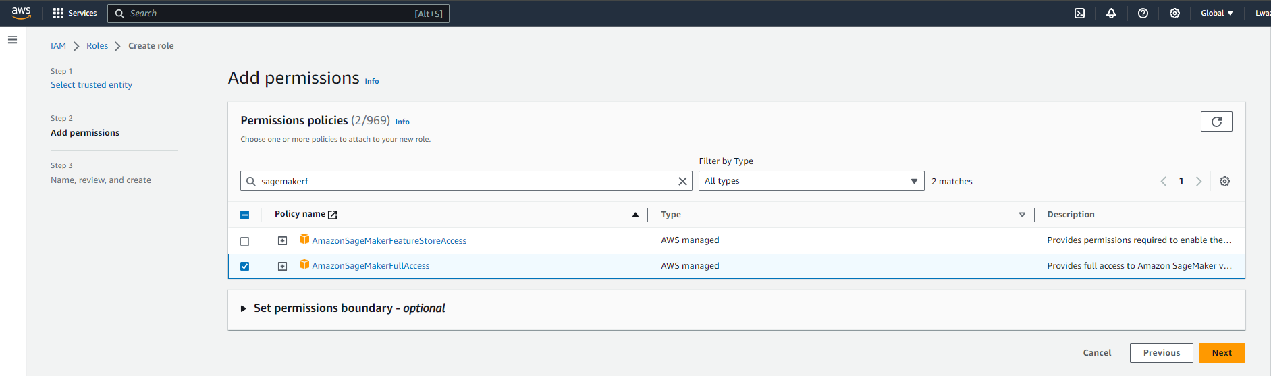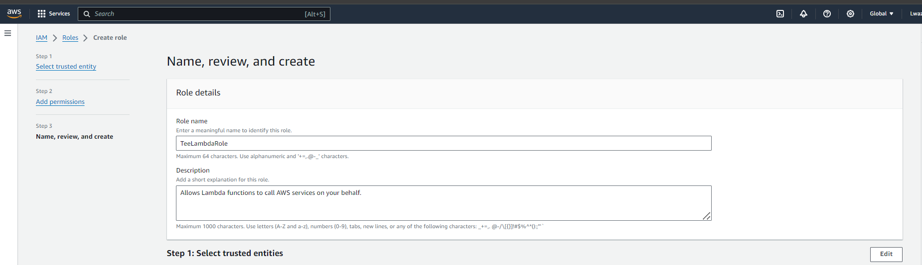

Back to configuration

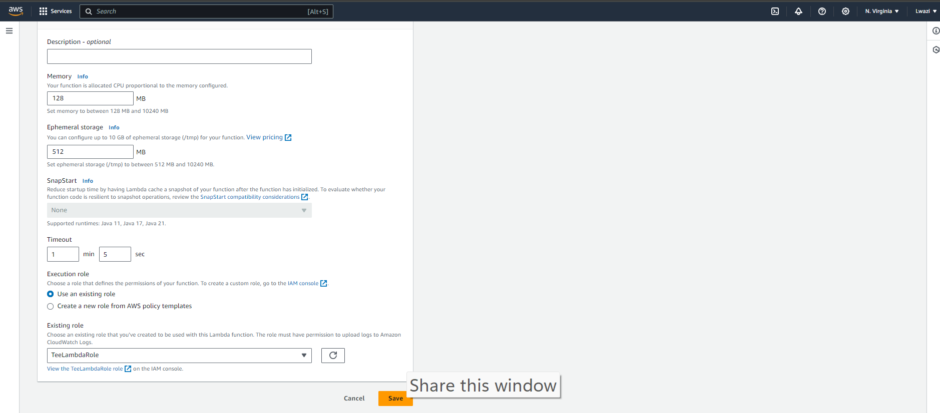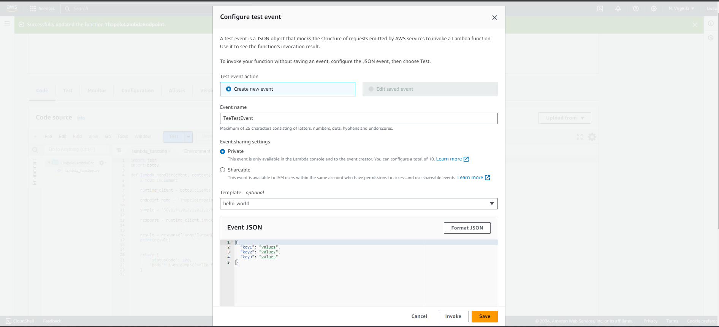

Deploying and testing: 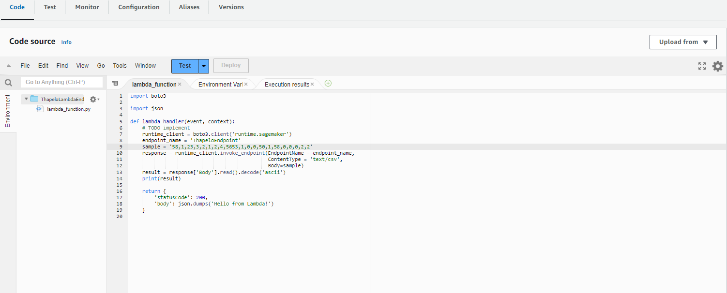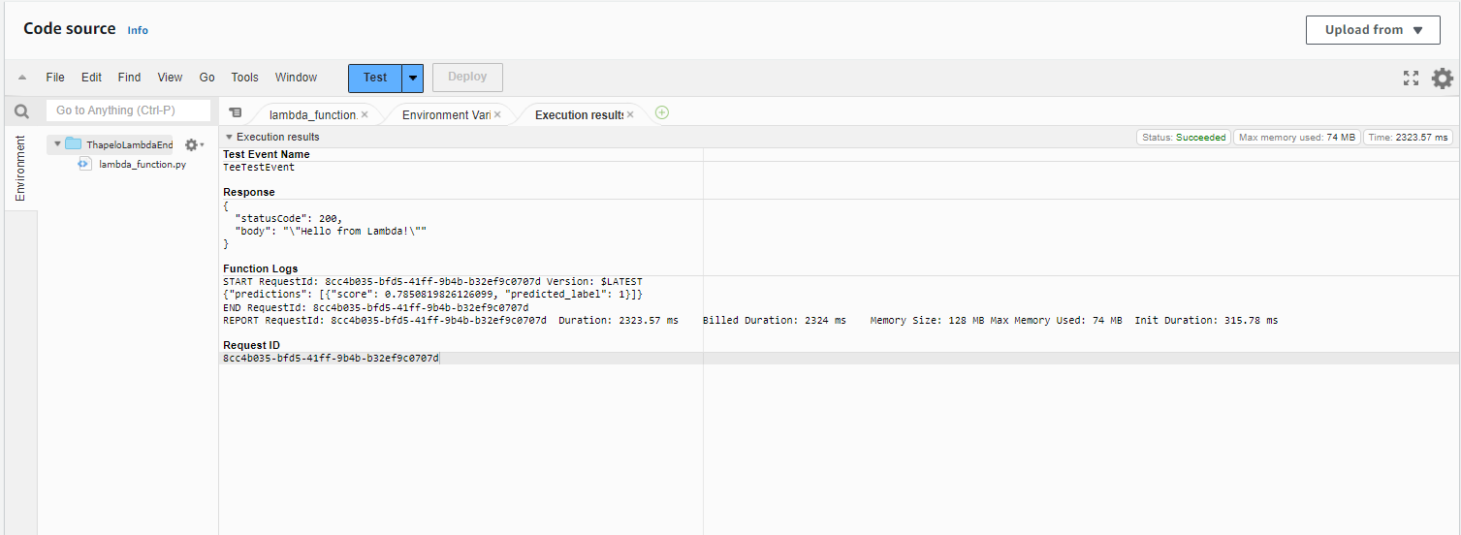

The expected result and the predicted result do match. However, the score is very low, meaning that there is very low accuracy in the predictions.